

| Title | Page no |
| --- | --- |
| Preface |  |
| Acknowledgement |  |
| Introduction |  |
| * EXISTING SYSTEM |  |
| * LIMITATION OF EXISTING SYSTEM |  |
| Proposed system |  |
| * PROJECT PROFILE |  |
| * INTRODUCTION |  |
| * BASIC FUNCTIONALITY OR SCOPE |  |
| * OBJECTIVE |  |
| INTRODUCTION TO DEVELOPMENT ENVIRONMENT |  |
| * WHAT IS PHP? |  |
| * MYSQL |  |
| SYSTEM PLANNING |  |
| * FEASIBILITY STUDY |  |
| * RISK MANAGEMENT |  |
| * PROJECT PLAN |  |
| * PROCESS MODEL |  |
| SYSTEM REQUIREMENT SPECIFICATION |  |
| * SYSTEM REQUIREMENT |  |
| * MODULE SPECIFICATION |  |
| SYSTEM DESIGN |  |
| * TASK DEPENDENCY DIAGRAM |  |
| * TIME LINE CHART |  |
| * DATA FLOW DIAGRAM |  |
| * PROCESS SPECIFICATION |  |
| * DATA TABLE |  |
| USER INTERFACE |  |
| SOFTWARE TESTING |  |
| * UNIT TESTING |  |
| * SYSTEM TESTING |  |
| * PERFORMANCE TESTING |  |
| * HUMAN FACTOR TESTING |  |
| WEBOGRAPHY |  |
|  |  |



The main objective of this project is to provide an all-in-one system for managing textile inventory, product and category records, staff activities, payment and customer record and also business operation via a dedicated web platform.

Here, therefore we submit this project on **TEXTILE MANAGEMENT SYSTEM** for company purposes. It was a wonderful experience to make this project.

We feel a great sense of accomplishment in presenting this project. This report was prepared on the basis of the information collected and developed during the project. We have taken care to ensure that the information included in this report is true and that the developed system is running smoothly and without any problem and we sincerely apologize if there are any mistakes or incorrect information.



Developing a project was never an easy task. Developing this project was a required component of the B.Sc. IT Semester 5curriculum**.** We had a great challenge in developing a good and satisfactory project. It was a challenge because till now whatever we were doing in practical work was as per instructed by our professor. But this time we had to perform our work on our own and developing this project was a required component of the B.Sc. IT Semester 5 curriculum.

From the starting of this project we got guidance and help from our professor, whenever we needed. We are thankful to Kishorsinh Vala sir and all staff members who helped and guided us in some way or the other when we were in trouble.

At this stage, the preparation of **“TEXTILE MANAGEMENT SYSTEM”** is the happiest event of our life. On this successful completion of our project, we must acknowledge the support and timely help of our friends and family members.

**EXISTING SYSTEM**

In most textile businesses, the management process is still carried out using manual methods or basic standalone applications like spreadsheets. Record keeping for inventory, sales, purchase, and customer details is done either on paper or through simple digital tools that are not fully integrated.

Currently, most textile businesses manage their operations using either manual methods or basic mobile applications.

1. **Manual / Traditional System**
   * Businesses rely on registers, notebooks, and spreadsheets to maintain records of sales, purchases, and stock.
   * Orders are often communicated informally (phone/WhatsApp), and accounts are handled manually.
   * While simple, this approach is time-consuming, prone to human error, and difficult to scale as the business grows.
2. **Existing Mobile Applications (e.g., VASTRA App)**
   * Some businesses use apps like VASTRA, which provide **digitization** but don’t have web applications for textile operations.
   * These apps help with basic processes such as billing, inventory tracking, and customer records.
   * They reduce paperwork but still have limitations in terms of accessibility and customization. Their costs are very high and they also do not have roll based access.

**LIMITATION OF EXISTING SYSTEM**

Despite the presence of both manual record-keeping and partially digital applications (like vastra), existing systems in textile business management face several drawbacks. These limitations create operational inefficiency and restrict the growth of textile businesses.

**1. Data management issues**

* **Error-prone records** – manual entry in registers or spreadsheets often leads to mistakes in calculations and duplication of data.
* **Data loss risk** – paper-based records are vulnerable to damage, theft, or misplacement.

**2. Limited accessibility**

* Manual systems can only be accessed at a single physical location.
* Mobile-only apps like vastra restrict usage to smartphones, making it difficult to access through the web .

**3. Limited reporting and insights**

* Manual systems provide no business insights beyond basic calculations.
* Business owners cannot track trends such as most-selling items, new inquiries, or pending payments effectively.

**4. Security concerns**

* Paper-based records lack security measures and can be accessed by unauthorized personnel.
* Spreadsheets stored on local devices are not encrypted and can be accidentally deleted.
* Existing apps also lack advanced security features like role-based access.

**5. No proper role management**

* In manual setups, everyone has access to the same records, which may lead to data manipulation.
* Existing apps often lack multi-user role assignment, meaning owners cannot assign permissions to their staff properly.

**6. Customization limitations and pricing concerns**

* Every textile business has unique workflows — different billing formats, tax requirements, and stock units. Existing apps like vastra offer limited customization.
* Basic packages do not allow businesses to design their own invoices, and in many cases, generated bills carry the app’s watermark. Only higher-priced plans allow custom bill formats, which increases the cost burden on small businesses.
* Vastra and similar apps charge around ₹10,000 per user, which is expensive for small textile traders or wholesalers.
* Moreover, this cost does not include inventory management. To access such features, businesses must upgrade to higher packages, further increasing their budget.

**PROPOSED SYSTEM:-**



**Front End Tool:**

* PHP

**Back End Tool:**

* My SQL

**Guide:**

* Kishorsinh vala

**Submitted to**

* Geetanjali College of Computer Science

**Developed By:**

* Maunish Sanjay Bhai Prajapati
* Dhruvish Ashok Bhai Lathiya

**INTRODUCTION**

This project is developed with the purpose of providing any textile company with a system to manage product, stock, categories, customers, invoices, and staff activities in an easy way. This software is developed with the purpose of textile inventory and business management.

When an admin wants to add products, update stock, register customers, or generate invoices, they can directly do it also staff have access to generate invoice, add inquiry and customers through the system instead of managing everything manually. Sometimes, in manual work, there can be mismanagement of stock, delay in billing, or confusion in customer records.

So, we thought about this problem and finally this textile management system was designed for the helping purpose of textile businesses.

**Feature:-**

* Admin Panel
  + User Authentication
  + Dashboard
  + Product
  + Category
  + Stock
  + Customer
  + Inquiry
  + Invoice
  + Attendance
  + User management
  + Payment
  + Weblink
  + Log
  + Stock and payment alert
* User Panel
  + User Authentication
  + Dashboard
  + Product
  + Category
  + Stock
  + Customer
  + Inquiry
  + Invoice
  + Attendance
  + Weblink

**BASIC FUNCTIONALITY:-**

It may help textile business owners to manage textile business functions very simply and efficiently. When an admin wants to add products, update stock, register customers, or generate invoices, they can directly do it also manage attendance of staff. Staff have access to generate invoice, add inquiry and customer through the system instead of managing everything manually. Both admin and staff can generate a product's web link and send them to the customer for product viewing purpose without entering into the system.

Our System also has alert functionalities when stock is low then the alert will send to the telegram group of business automatically also whenever invoice is generated then also alert is sent.

We have tried to computerize the textile business process.

**SCOPE:-**

* It also planning to integrate the other modules in our system that provide more facility to the Business owner.
* Our next plan is to add REST API development for third-party integrations.
* We will also add Advanced analytics and business intelligence features.
* E-commerce integration for online sales channels
* Mobile application for on-the-go inventory management

**OBJECTIVE**

The objective of this project is to create a web-based Textile Management System that helps the admin and staff manage textile business operations in an organized way. The system allows the admin to manage products, categories, stock, customers, invoices, payments, attendance, and more. Staff members can view products, categories, stock, and customers, and can manage customer inquiries, generate invoices, and track attendance. The goal is to make the daily operations easier and more efficient using a simple and secure platform built with PHP and MySQL.

∙ Develop a well-designed database to store textile business information.

∙ Easy retrieval of product, customer, and invoice details.

∙ Efficient management of stock, payments, and attendance records.

* To generate reports for sales, stock, invoices, and customer inquiries for better decision making. Provide secure login access for admin and staff to ensure data protection.
* Allow the admin to manage and monitor all business activities from a single platform

**INTRODUCTION TO DEVELOPMENT ENVIRONMENT:**

***WHAT IS PHP?***

PHP is a server-side scripting language that is embedded in HTML. It is used to manage dynamic content, databases, session tracking, even build entire e-commerce sites. Although it is especially suited to web development, you can also build desktop standalone applications as PHP also has a command-line interface.

* PHP is a cross-platform language, capable of running on all major operating system platforms and with most of the web server programs
* PHP performs system functions. It can create, open, read, write, and close the files.
* PHP can handle forms. It can gather data from files, save data to a file, through email you can send data, return data to the user.
* You add, delete, modify elements within your database through PHP.
* Access cookies variables and set cookies.
* Using PHP, you can restrict users to access some pages of your website.
* It can encrypt data.

MYSQL

MySQL is a very popular open-source relational database management system

* MySQL is a relational database management system
* MySQL is open-source
* MySQL is free
* MySQL is ideal for both small and large applications
* MySQL is very fast, reliable, scalable, and easy to use
* MySQL is cross-platform
* MySQL is compliant with the ANSI SQL standard
* MySQL was first released in 1995
* MySQL is developed, distributed, and supported by Oracle Corporation

**SYSTEM PLANNING:-**

**FEASIBILITY STUDY:-**

Feasibility study aims to uncover the strength and weaknesses of the proposed project objectively and rationally. A feasibility study analyses the viability of a project to determine whether the project or venture is likely to succeed. The study is also designed to identify potential issues and problems that could arise while pursuing the project.

**Technical feasibility:-**

All the members of the group are familiar with PHP, so it helped us to work upon this project.

**Schedule feasibility :-**

The project has been chosen keeping in mind the scheduling of the project. The estimated time is feasible to complete the project.

**RISK MANAGEMENT:-**

An ineffective management system in the textile business can cause problems in many, sometimes unexpected, ways. Managing products, stock, payments, and attendance without proper tools can lead to confusion and unnecessary costs. By using a web-based Textile Management System, it becomes easier to keep operations organized and efficient, reducing risks for the business.

1. **Higher Costs**

* Extra man-hours are spent searching for product, stock, or payment information.
* Mistakes in managing stock or invoices can lead to financial losses.
* Manual processes waste time and resources that could be used elsewhere.

1. **Reduced Efficiency**

* Without proper tracking, employees may not know which stock is low or which payments are pending.
* Confusion in handling customer inquiries or invoices can slow down operations and reduce productivity.

1. **Inaccurate Inventory and Stock Management**

* Poor stock tracking can result in either overstocking or stock shortages, both of which increase costs.
* Over-reliance on manual checking may lead to errors in recording stock and sales, affecting planning and decision-making.

1. **Disorder Across Operations**

* If stock, invoices, and customer details are not properly managed, it can create disorder in the daily workflow.
* Lack of alerts and logs can cause delays in responding to customer requests or restocking items.
* Disorganization in one part of the business spreads to other areas, affecting sales, customer satisfaction, and overall efficiency.

1. **Security Risks**

* Without proper access control, unauthorized users may view or modify sensitive business information.

1. **Compliance and Legal Issues**

* Incomplete or inaccurate records related to payments, stock, or attendance can lead to compliance problems.
* The business may face audits, penalties, or disputes if proper documentation is not maintained.

With a proper Textile Management System, these risks can be minimized by providing clear records, real-time alerts, and a secure platform to manage operations smoothly.

***PROJECT PLAN***

| **No** | **Task** | **Start Date** | **End Date** | **Assigned to** |
| --- | --- | --- | --- | --- |
| **1.** | Collect info. | 15/6/2025 | 19/6/2025 | Both Partners |
| **2.** | Gather info. | 20/6/2025 | 25/6/2025 | Both Partners |
| **3.** | Determine Scope | 26/6/2025 | 30/6/2025 | Both Partners |
| **4.** | Data Analyses | 1/7/2025 | 6/7/2025 | Both Partners |
| **5.** | Different module | 7/7/2025 | 14/7/2025 | Both Partners |
| **6.** | Database Table | 15/7/2025 | 24/7/2025 | Both Partners |
| **7.** | UI Of module | 25/7/2025 | 2/8/2025 | Both Partners |
| **8.** | Basic interface | 2/8/2025 | 15/8/2025 | Both Partners |
| **9.** | Implement Logic | 16/8/2025 | 31/8/2025 | Both Partners |
| **10.** | Database Connect | 1/9/2025 | 5/9/2025 | Both Partners |
| **11.** | Implement different module | 6/9/2025 | 18/9/2025 | Both Partners |
| **12** | Validation & Control | 19/9/2025 | 30/9/2025 | Both Partners |
| **13.** | Connectivity | 1/10/2025 | 11/0/2025 | Both Partners |
| **14.** | Completion– | 11/10/2025 | 15/10/2025 | Both Partners |

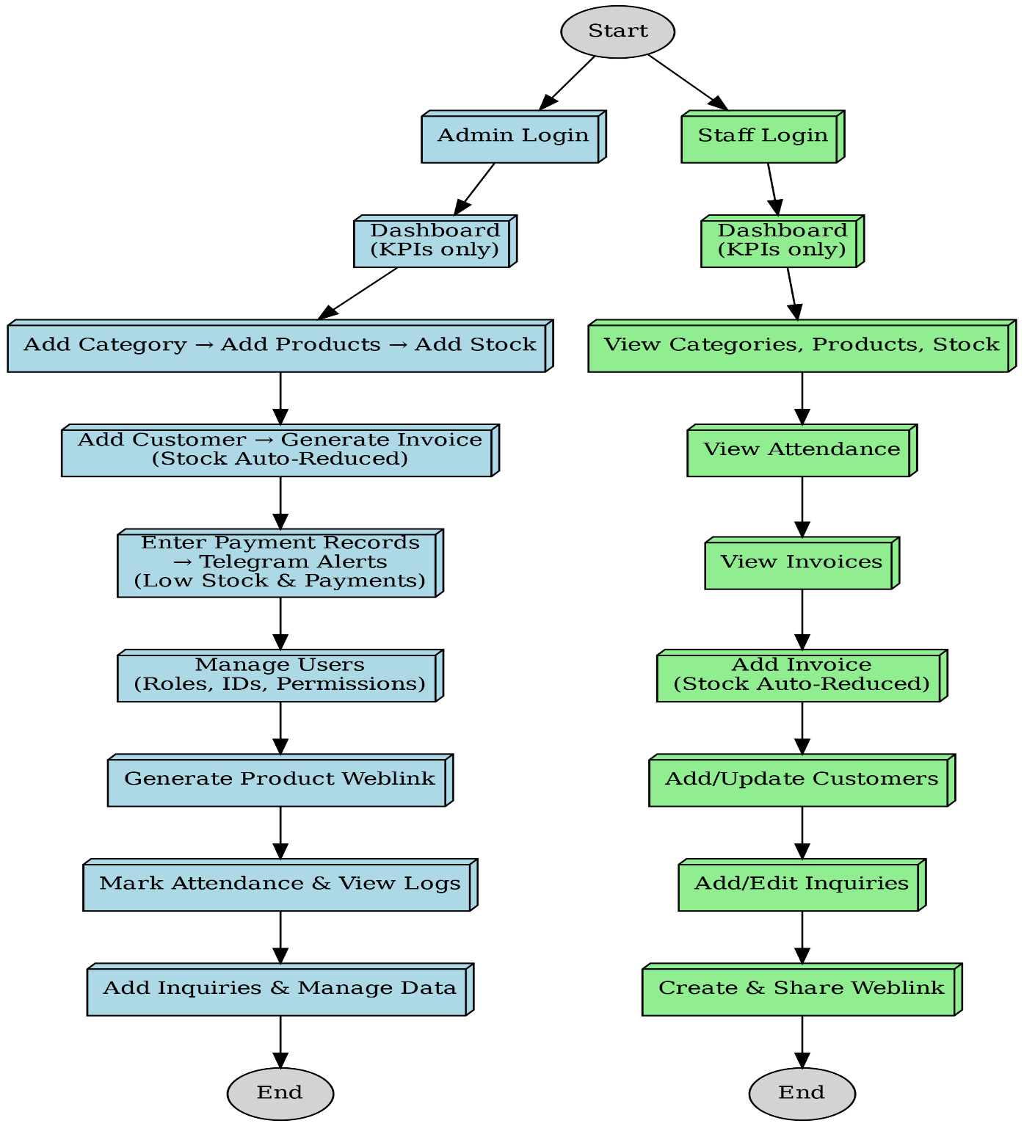

In this system, the process model used is “automated process management with manual inputs.”

The **Textile Management System** combines automation with manual data entry to streamline the management of stock, customer information, invoices, payments, and attendance for textile businesses. The system is designed with two panels—admin and staff—each with specific roles to ensure smooth daily operations.

The admin panel allows users to add categories, products, customers, and stock, and to generate invoices. While some tasks like entering payments or marking attendance are performed manually, routine processes such as reducing stock after generating an invoice, sending alerts for low stock or new payments, and updating dashboards with KPIs are automated to enhance efficiency. Admins can also manage users, create product view links, and oversee attendance and business inquiries from a centralized dashboard.

The staff panel provides controlled access to view categories, products, and stock, and enables staff to add invoices, customers, and inquiries. Automation ensures that tasks like stock updates and alerts are handled seamlessly once data is entered.

**Process automation** is defined as the use of software and technologies to carry out repetitive or structured tasks based on predefined rules, while manual data entry supports inputs that require human judgment or verification. This hybrid approach helps businesses improve accuracy, save time, and reduce errors while allowing flexibility where human intervention is necessary.

The Textile Management System, therefore, leverages automation to simplify core operations while incorporating manual inputs where required, making it an effective tool for improving productivity and operational oversight in textile businesses.

***SYSTEM REQUIREMENT SPECIFICATION***

**SYSTEM REQUIREMENT**

The efficient hardware & software configuration requires to run the system as suggested, The configuration suggested is for better performance, same functionality or higher configuration always better.

***Admin***

| Software | Web Server(preferably Apache) |
| --- | --- |
| Operating System | Windows |
| Browser | Google chrome, Internet Explorer |
| Database | MySQL |
| Microprocessor | Any But Latest is Good for performance |

***Staff***

| Software | Web Server(preferably Apache) |
| --- | --- |
| Operating System | Windows |
| Browser | Google chrome, Internet Explorer |
| Database | MySQL |
| Microprocessor | Any But Latest is Good for performance |



**MODULE SPECIFICATION**

**1. Admin Panel:**

The admin panel contains the following tasks and functionalities:

* **Dashboard:**

The dashboard provides key information such as:

* Outstanding payments
* Today’s sales
* Weekly sales
* Payment deadlines
* Top 5 selling products
* Log activity with status  
  It helps the admin monitor the overall performance.
* **Category Management:**

This section allows the admin to add new categories for products based on their business. It also shows the automatic count of products added to that particular category.

* **Product Management:**

The admin can add, edit, delete, and view products under preferred category. It ensures proper tracking of textile items and also it has functionality to disable product from selling for some time and according to stock you can see the status of product like in stock out of stock on product page.

* **Stock Management:**

This section allows the admin to add, edit, delete, and view stock for each product. The stock is automatically reduced when invoices are generated. Stock edit option have limited access like user can only add stock or record deadstock sold stock cannot be manually updated due to security concerns.

* **Customer Management:**

The admin can add, edit, delete, and view customer information. This helps in maintaining accurate records and managing customer interactions effectively. This system has also functionality like when you click on customer name you can see their entire transaction history.

* **Invoice Management:**

The admin can generate invoices for customers and track sales. Once an invoice is created, the stock is automatically updated to reflect the transaction. Invoice is designed in such way that you just need to select the product all other details of product will fetch automatically only the product which have available currently in stock will only display in product list dropdown.

* **Payment Records:**

The admin can manually add or edit payment records and view payment details. Notifications are automatically sent to the Telegram group when a payment is added. Even the admin cannot delete the payment record.

* **Attendance Management:**

The admin can manually mark staff attendance, view attendance records, and monitor login activity to ensure accountability.

* **User Management:**

This module allows the admin to add new users, assign roles (admin or staff), generate IDs and passwords, and manage permissions for secure access.

* **Weblink Generation:**

The admin can create a separate product view link that allows customers to see available products without logging into the system.

* **Inquiry Management:**

The admin can add, view, edit, and manage business inquiries to track customer or staff concerns.

* **Alerts (Stock/Payment):**

Whenever stock is low or a payment is added, automatic alerts are sent to the business’s Telegram group to ensure timely action.

* **System Logs:**

The admin can view login activities and system usage to keep track of operational data.

**2. Staff Panel:**

The staff panel is designed to provide access to necessary functionalities with limited permissions for better control:

* **Dashboard:**

The staff dashboard displays:

* Total attendance
* Invoices generated by the staff
* Inquiries added by the staff
* Total sales made by the staff
* Customers added by the staff
* Outstanding payments overall
* Top-ranked staff by sales  
  This helps staff stay informed about their performance.
* **Category View:**

Staff can view categories but cannot add, edit, or delete them.

* **Product View:**

Staff can view product details but cannot manage product data.

* **Stock View:**

Staff can view current stock levels without making changes.

* **Customer Management:**

Staff can add new customers and update existing customer data, ensuring smooth customer interactions.

* **Invoice Management:**

Staff can generate invoices for customers. Once an invoice is created, the stock is automatically updated.

* **Attendance:**

Staff can view their attendance records.

* **Inquiry Management:**

Staff can add and edit inquiries related to their tasks or customers, helping maintain better communication and service.

* **Weblink Generation:**

Staff can create product view links and share them with customers so customers can view the product without entering into the system, improving product accessibility.

***SYSTEM DESIGN***

*TASK DEPENDENCY DIAGRAM*



Requirement

Gathering



Requirement

Analysis

















CODING &

MODUAL



***DATA FLOW DIAGRAM***

The data flow diagram are an intuitive way of showing How data is processed by a system The symbol used in the DFD for project are shown below.

* **Data flow:**

Following symbol is used to show data flow, the data flow is packet of data.



* **Process:**

People, procedure or device that use or produce data



* **Source:**

These are the entities which interact with the system from outside its boundaries.



* **Data storage:**

Here data are stored process in the system.





The DFD diagram we define the flow of data and the system data flow manged by grouping data with the entity relationship. In this way we found out the need of the system and managed particular way by which can easily access with the system.

We use of DFD Diagram all the complete data flow is understood by the system analysis.

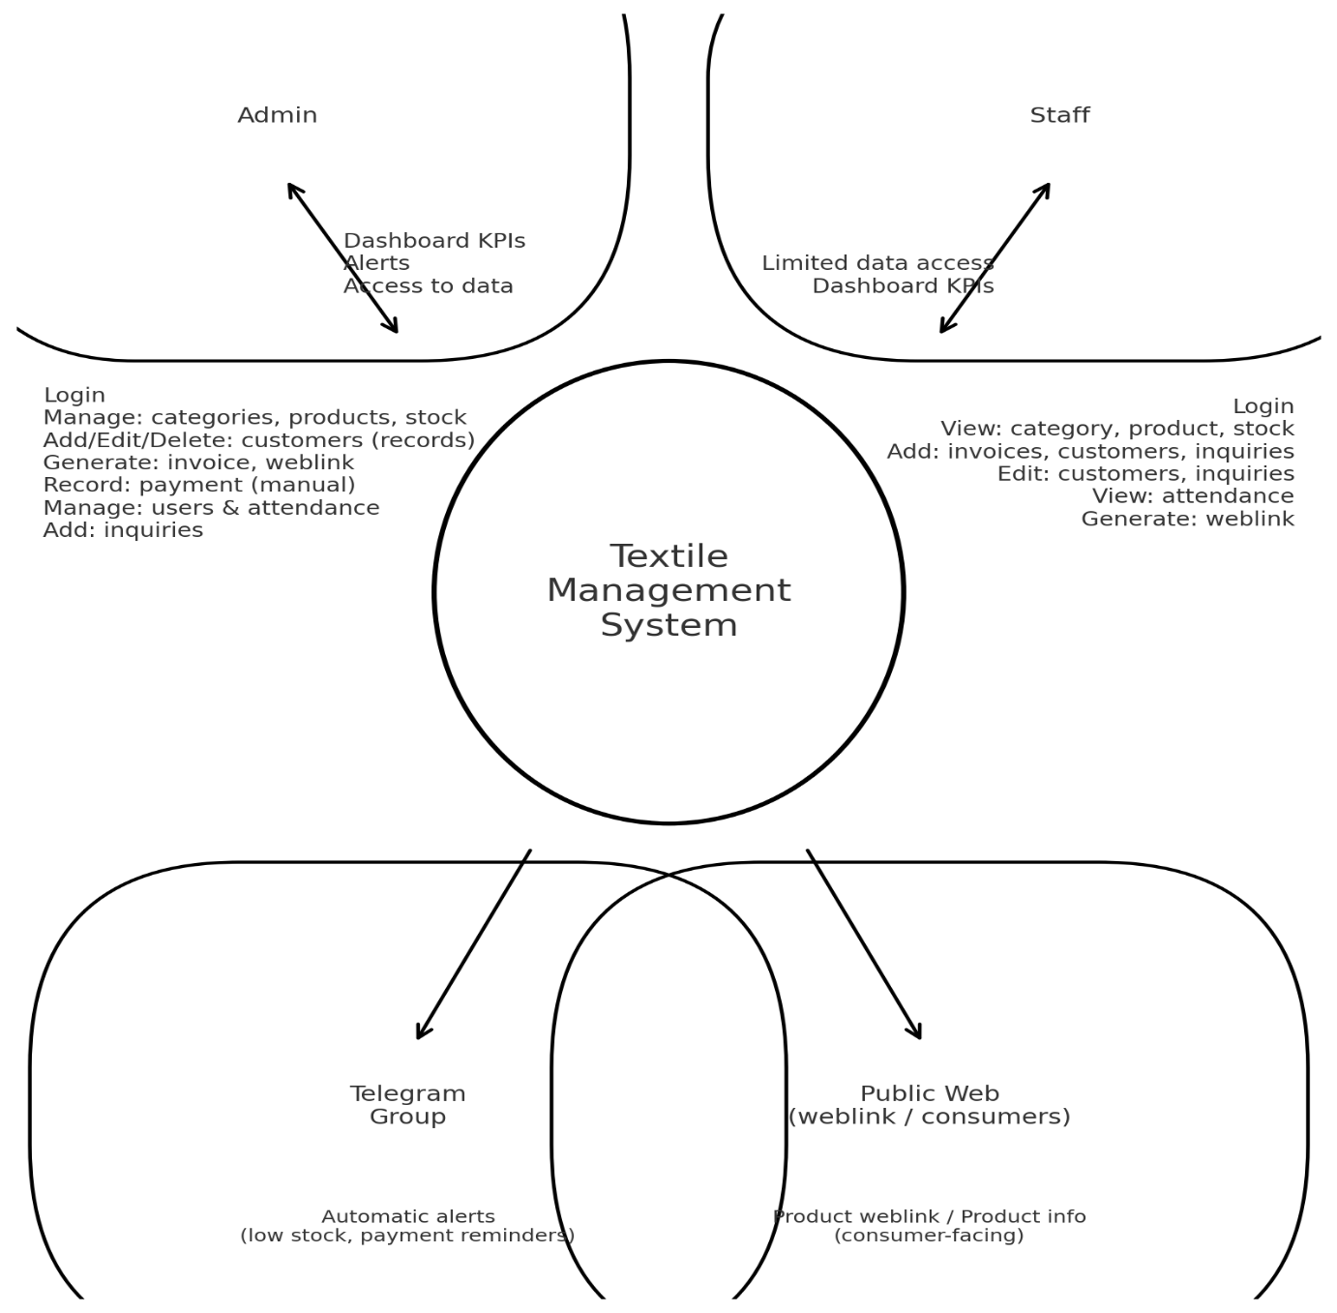

**DFD for adding a stock of product**

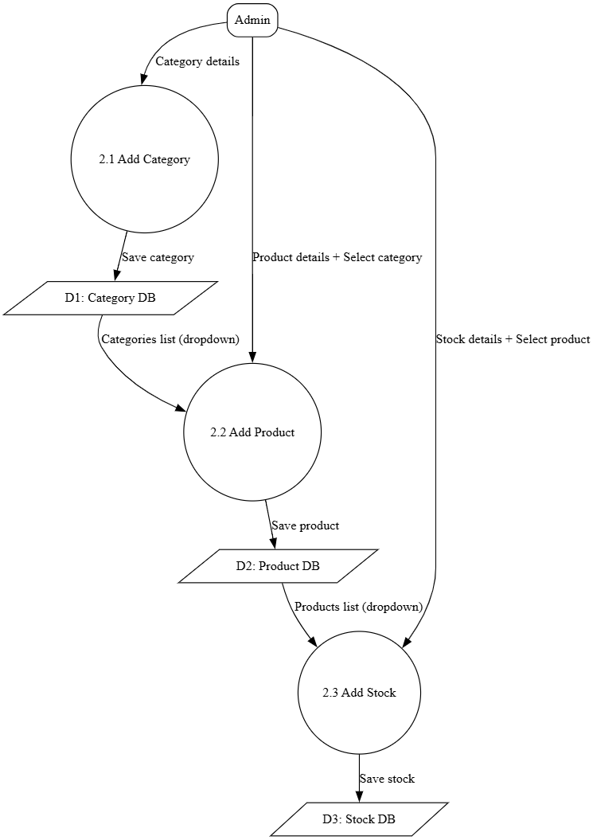

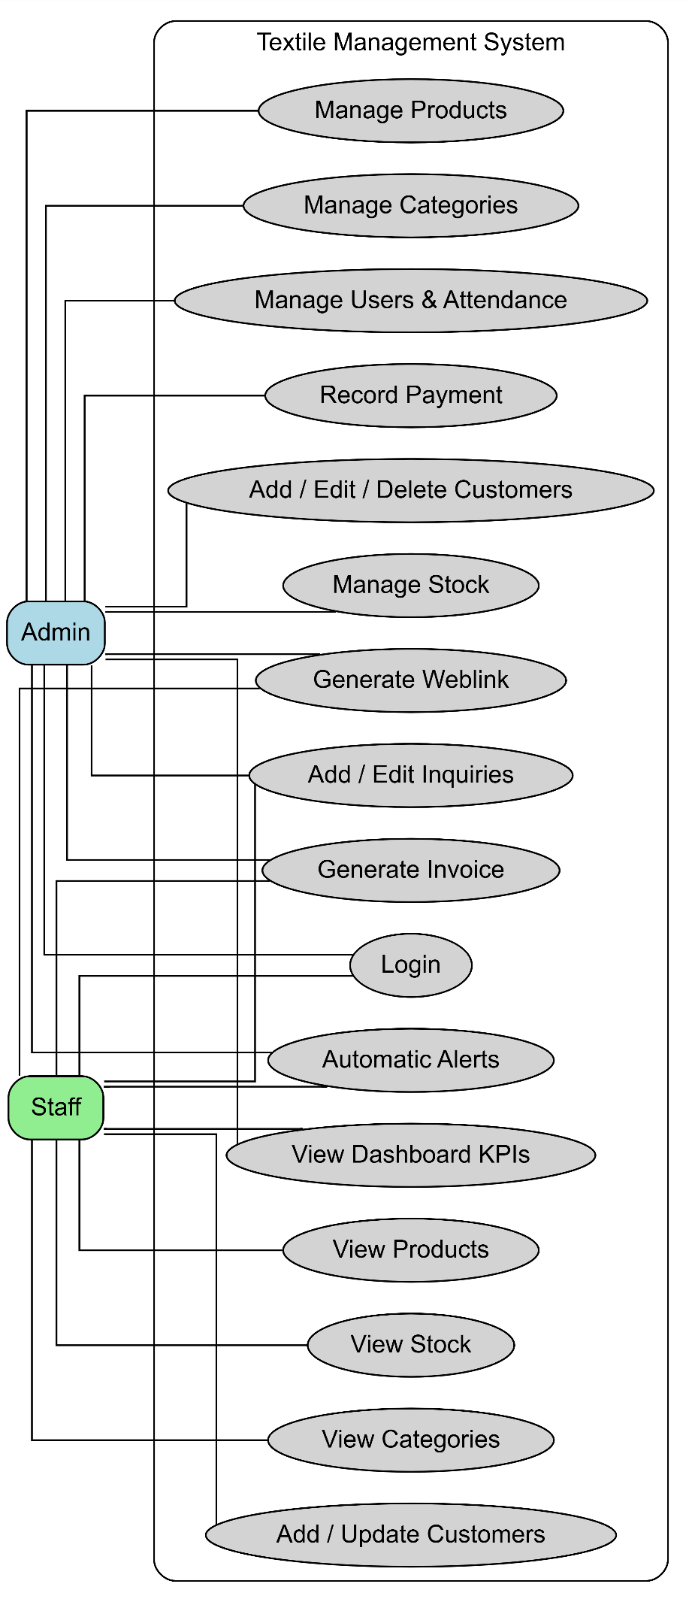

***PROCESS SPECIFICATION***

* **User authentication process:**

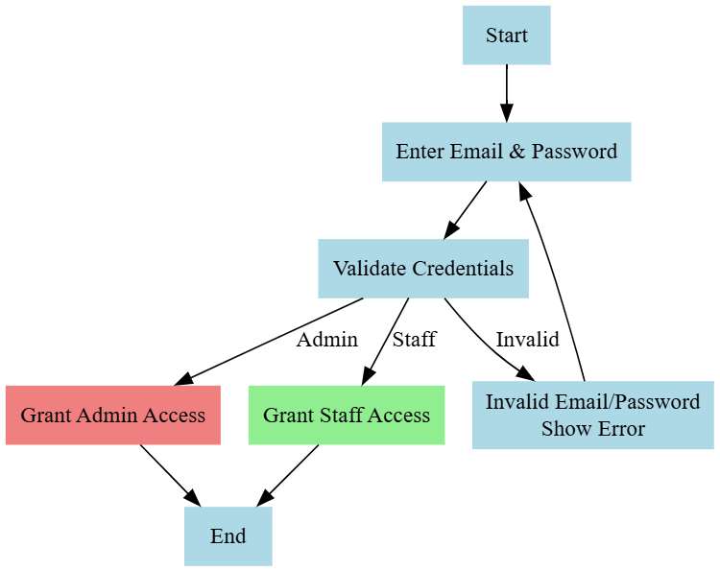

* **Stock addition process:**

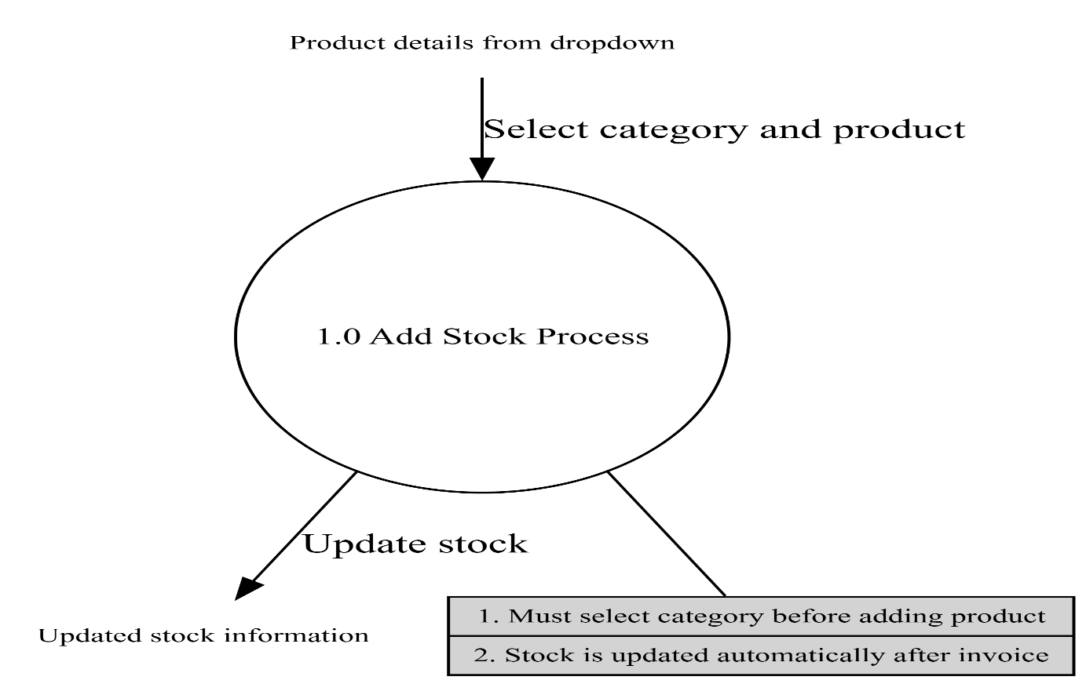

* **Invoice generation process:**

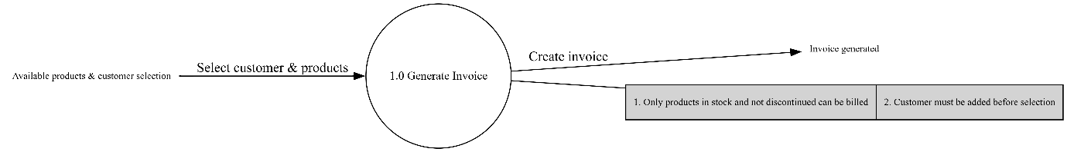

* **User add Process:**

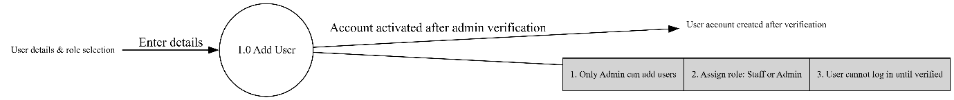

* **Weblink Creation:**

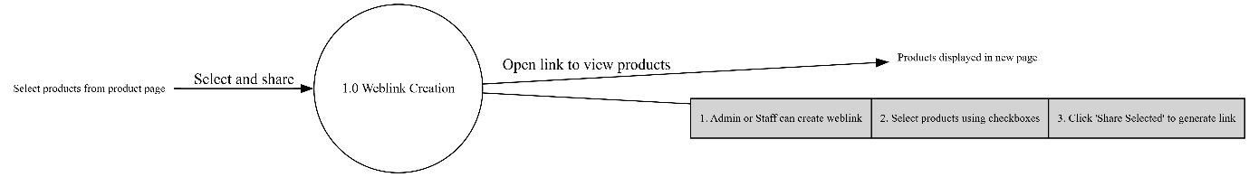

* **Stock and Payment alert:**

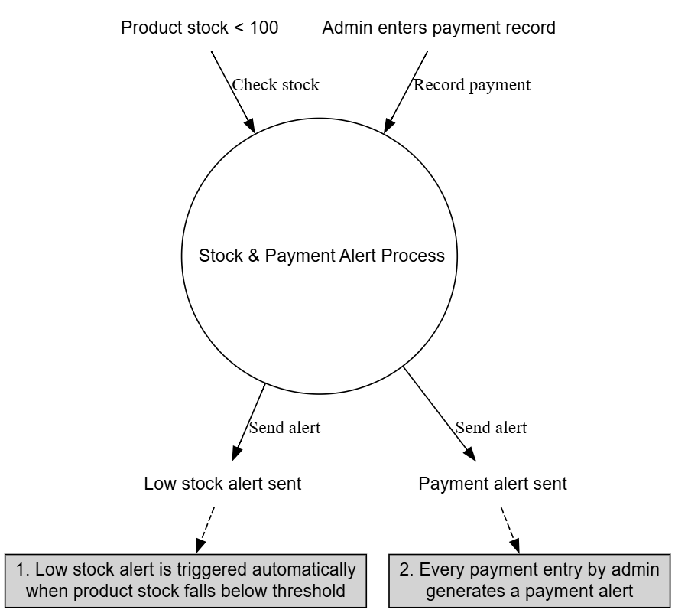

***Data Table***

1.attendance

| **FIELD** | **TYPE** | **NULL** | **KEY** | **DEFAULT** |
| --- | --- | --- | --- | --- |
| id | int(11) | No | Primary | Null |
| user_id | int(11) | No | Unique | Null |
| att_date | date | No |  | Null |
| status | enum(‘P’,’A’) | No |  | Null |

2.category

| **FIELD** | **TYPE** | **NULL** | **KEY** | **DEFAULT** |
| --- | --- | --- | --- | --- |
| id | int(11) | No | Primary | Null |
| description | text | Yes |  | Null |
| image | varchar(255) | Yes |  | Null |
| tag | varchar(100) | Yes |  | Null |

3.customer

| **FIELD** | **TYPE** | **NULL** | **KEY** | **DEFAULT** |
| --- | --- | --- | --- | --- |
| id | int(11) | NO | PRI | NULL |
| first_name | text | YES |  | NULL |
| last_name | text | YES |  | NULL |
| email | text | YES |  | NULL |
| phone | text | YES |  | NULL |
| dob | text | YES |  | NULL |
| gender | text | YES |  | NULL |
| address | text | YES |  | NULL |
| city | text | YES |  | NULL |
| state | text | YES |  | NULL |
| zip | text | YES |  | NULL |
| country | text | YES |  | NULL |
| reference_name | text | YES |  | NULL |
| notes | text | YES |  | NULL |
| profile_image | text | YES |  | ‘f’ |
| total_amount | text | YES |  | ‘0’ |

4.inquiry

| **FIELD** | **TYPE** | **NULL** | **KEY** | **DEFAULT** |
| --- | --- | --- | --- | --- |
| id | int(11) | NO | PRI | NULL |
| name | varchar(255) | NO |  | NULL |
| email | varchar(255) | NO |  | NULL |
| phone | varchar(20) | YES |  | NULL |
| message | text | NO |  | NULL |
| status | tinyint(4) | YES |  | 0 |
| created_at | timestamp | NO |  | current_timestamp() |
| created_by | Int(11) | NO |  | NULL |
| updated_at | Int(11) | YES |  | NULL |
| updated_by | timestamp | NO |  | current_timestamp() |

5.invoices

| **FIELD** | **TYPE** | **NULL** | **KEY** | **DEFAULT** |
| --- | --- | --- | --- | --- |
| id | int(11) | NO | PRI | NULL |
| customer_id | varchar(100) | YES |  | NULL |
| invoice_date | date | YES |  | NULL |
| due_date | date | YES |  | NULL |
| account_number | varchar(50) | YES |  | NULL |
| bank_name | varchar(100) | YES |  | NULL |
| swift_code | varchar(50) | YES |  | NULL |
| notes | text | YES |  | NULL |
| subtotal | decimal(12,2) | YES |  | 0.00 |
| discount | decimal(12,2) | YES |  | 0.00 |
| tax | decimal(12,2) | YES |  | 0.00 |
| total | decimal(12,2) | YES |  | 0.00 |
| created_at | timestamp | NO |  | current_timestamp() |
| created_by | int(11) | NO |  | NULL |
| updated_by | int(11) | YES |  | NULL |

6.invoice_items

| **FIELD** | **TYPE** | **NULL** | **KEY** | **DEFAULT** |
| --- | --- | --- | --- | --- |
| id | int(11) | NO | PRI | NULL |
| invoice_id | int(11) | NO |  | NULL |
| product_id | varchar(255) | YES |  | NULL |
| rate | decimal(12,2) | YES |  | 0.00 |
| quantity | int(11) | YES |  | 1 |
| amount | decimal(12,2) | YES |  | 0.00 |
| taxable | tinyint(1) | YES |  | 0 |

7.payments

| **FIELD** | **TYPE** | **NULL** | **KEY** | **DEFAULT** |
| --- | --- | --- | --- | --- |
| id | int(11) | NO | PRI | NULL |
| invoice_id | int(11) | NO |  | NULL |
| payment_date | date | YES |  | curdate() |
| amount_paid | decimal(12,2) | NO |  | NULL |
| payment_  method | enum('cash','card','bank_transfer','upi','cheque') | YES |  | cash |
| reference_  number | varchar(100) | YES |  | NULL |
| notes | text | YES |  | NULL |
| created_at | timestamp | NO |  | current_timestamp() |
| created_by | int(11) | NO |  | NULL |
| updated_by | int(11) | YES |  | NULL |

8.products

| **FIELD** | **TYPE** | **NULL** | **KEY** | **DEFAULT** |
| --- | --- | --- | --- | --- |
| id | int(11) | NO | PRI | NULL |
| name | varchar(255) | NO |  | NULL |
| description | text | YES |  | NULL |
| category | varchar(100) | YES |  | NULL |
| regular_price | decimal(10,2) | YES |  | NULL |
| sale_price | decimal(10,2) | YES |  | NULL |
| includes_tax | tinyint(1) | YES |  | 0 |
| in_stock | tinyint(1) | YES |  | 0 |
| show_publicly | tinyint(1) | YES |  | 1 |
| disabled | tinyint(1) | YES |  | 0 |
| created_at | timestamp | NO |  | current_timestamp() |
| updated_at | timestamp | NO |  | current_timestamp() |
| images | varchar(255) | YES |  | NULL |

9.stock

| **FIELD** | **TYPE** | **NULL** | **KEY** | **DEFAULT** |
| --- | --- | --- | --- | --- |
| id | int(11) | NO | PRI | NULL |
| product_id | int(11) | YES |  | NULL |
| product_name | varchar(255) | YES |  | NULL |
| current_stock | int(11) | NO |  | 0 |
| sold_stock | int(11) | YES |  | NULL |
| dead_stock | int(11) | YES |  | NULL |
| pending_stock | int(11) | YES |  | NULL |
| last_updated | timestamp | NO |  | current_timestamp() |

10. users

| **FIELD** | **TYPE** | **NULL** | **KEY** | **DEFAULT** |
| --- | --- | --- | --- | --- |
| id | int(11) | NO | PRI | NULL |
| is_verified | tinyint(1) | NO |  | 0 |
| name | text | NO |  | NULL |
| email | text | NO |  | NULL |
| password | text | NO |  | NULL |
| mobile_no | bigint(20) | YES |  | NULL |
| role | text | NO |  | staff |
| profile_picture | text | YES |  | avatar.png |
| auth_provider | text | NO |  | local |
| created_by | int(11) | NO |  | NULL |
| created_at | timestamp | NO |  | current_timestamp() |

11.user_log

| **FIELD** | **TYPE** | **NULL** | **KEY** | **DEFAULT** |  |  |  |  |  |
| --- | --- | --- | --- | --- | --- | --- | --- | --- | --- |
| id | int(11) | NO | PRI | NULL |  |  |  |  |  |
| user_id | int(11) | NO |  | NULL |  |  |  |  |  |
| email | text | NO |  | NULL |  |  |  |  |  |
| is_success | tinyint(1) | NO |  | 0 |  |  |  |  |  |
| login_time | timestamp | NO |  | current_timestamp() |  |  |  |  |  |

12.weblink

| **FIELD** | **TYPE** | **NULL** | **KEY** | **DEFAULT** |
| --- | --- | --- | --- | --- |
| id | int(11) | NO | PRI | NULL |
| createby | int(11) | NO |  | NULL |
| createat | timestamp | NO |  | current_timestamp() |
| productIds | text | YES |  | NULL |

***User Interface***

* Admin Dashboard

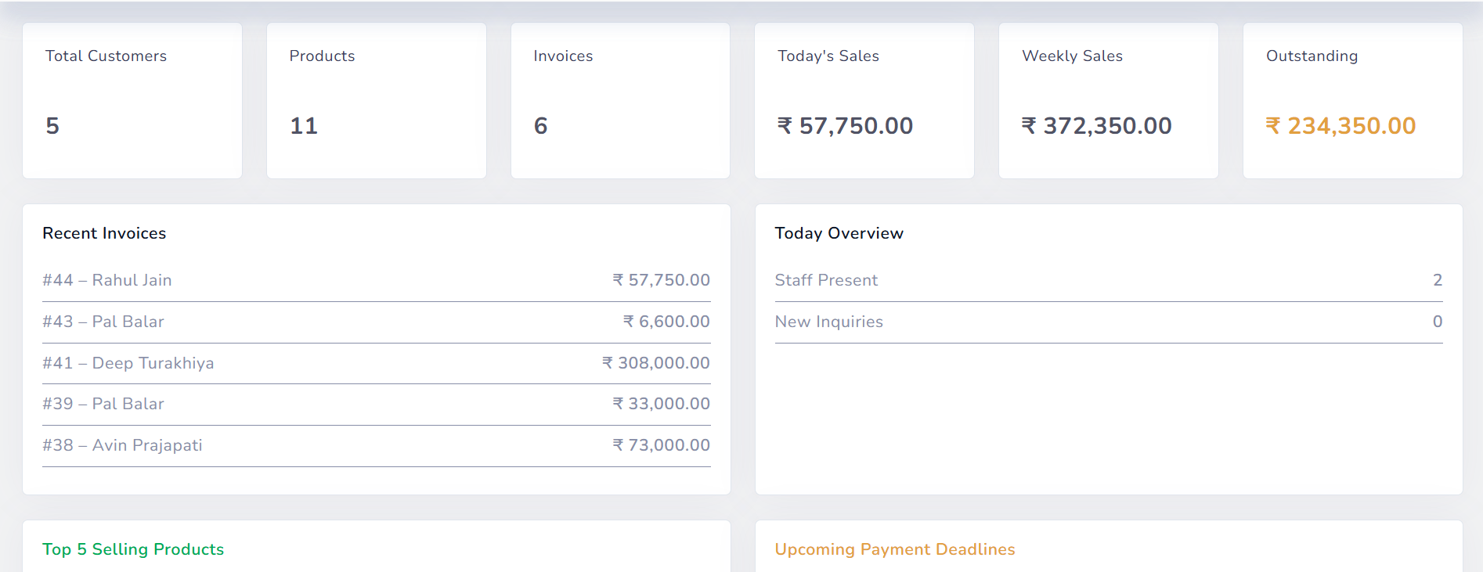

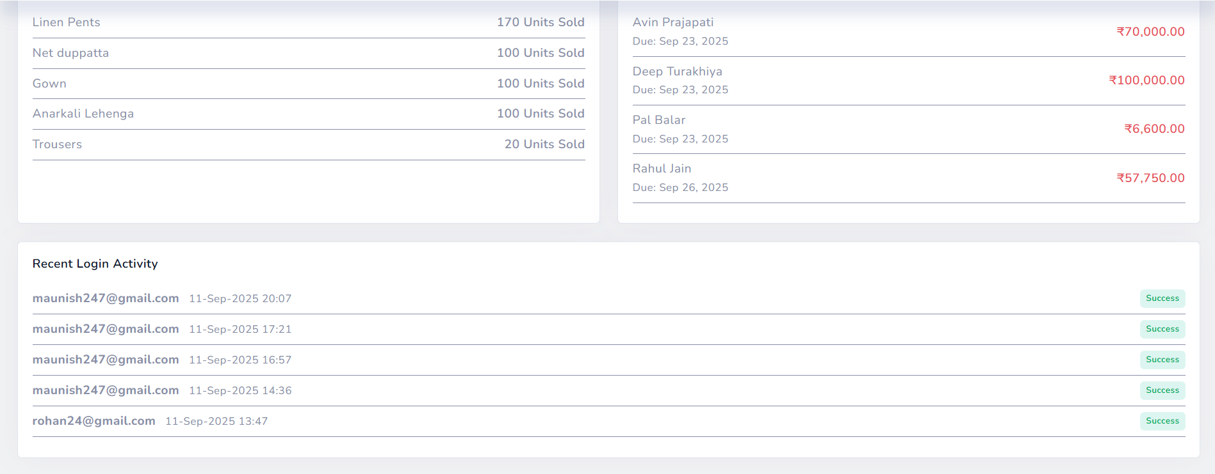

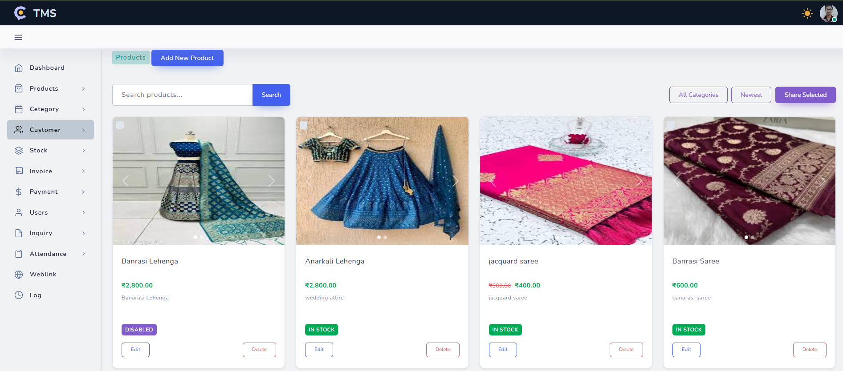

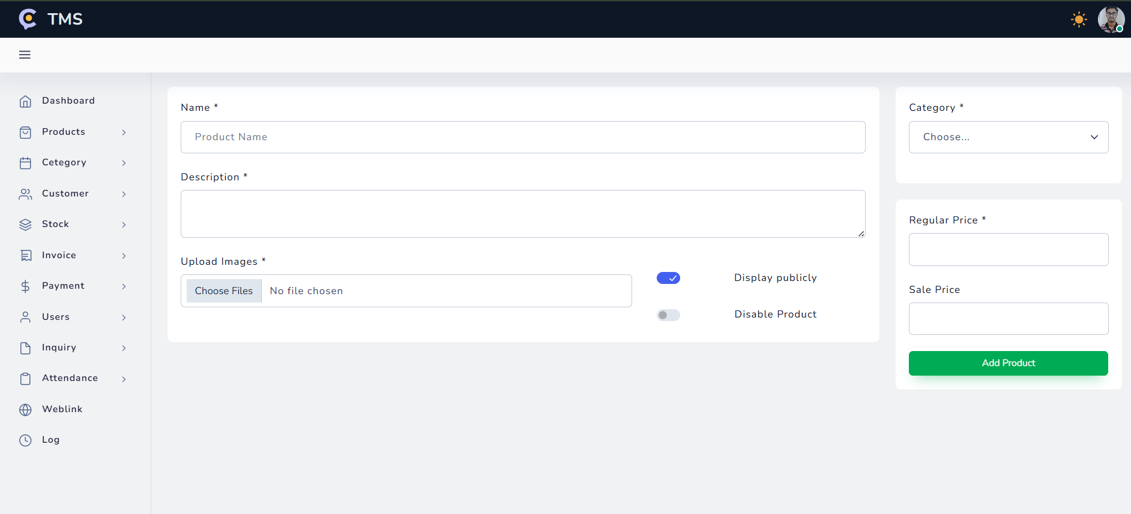

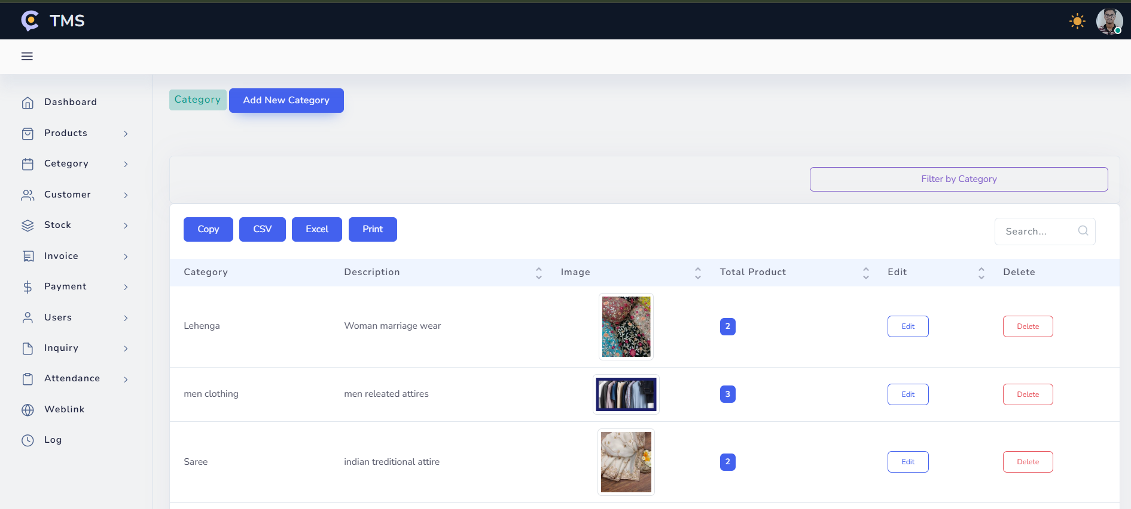

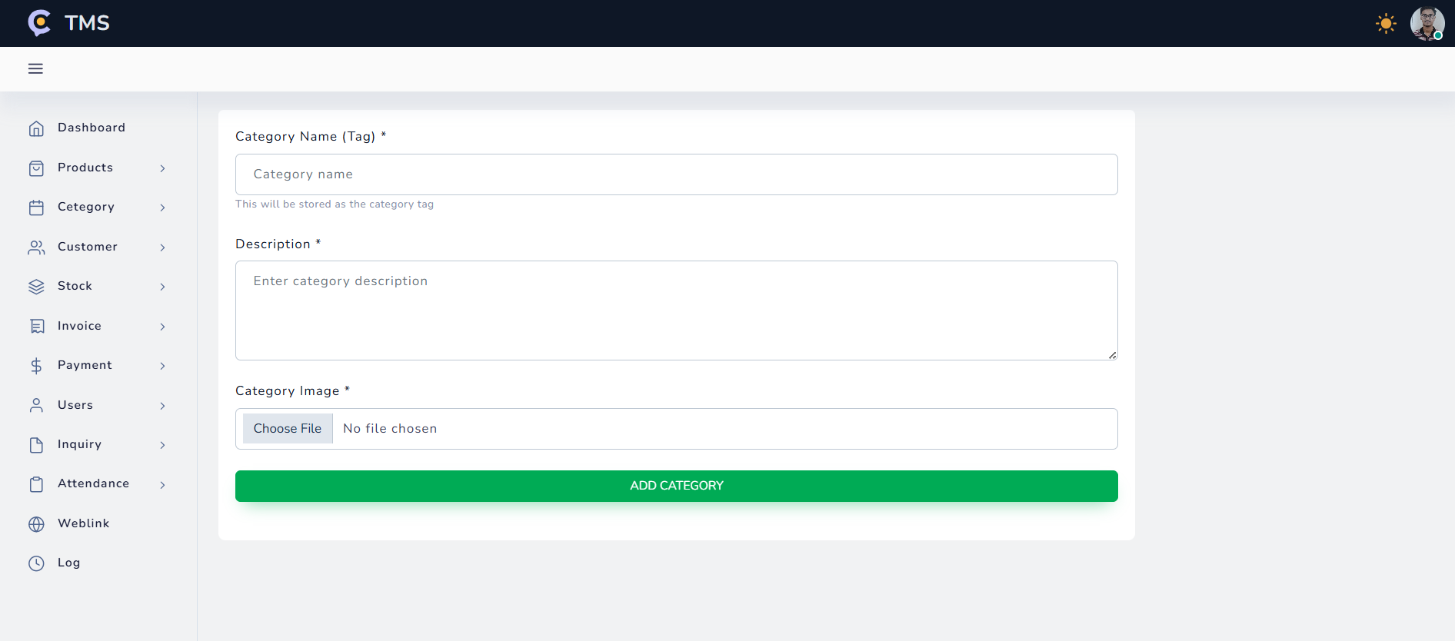

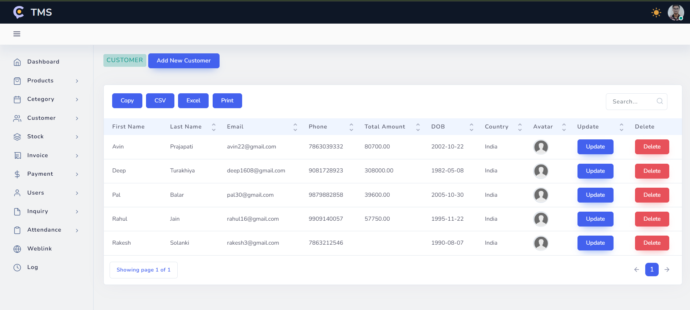

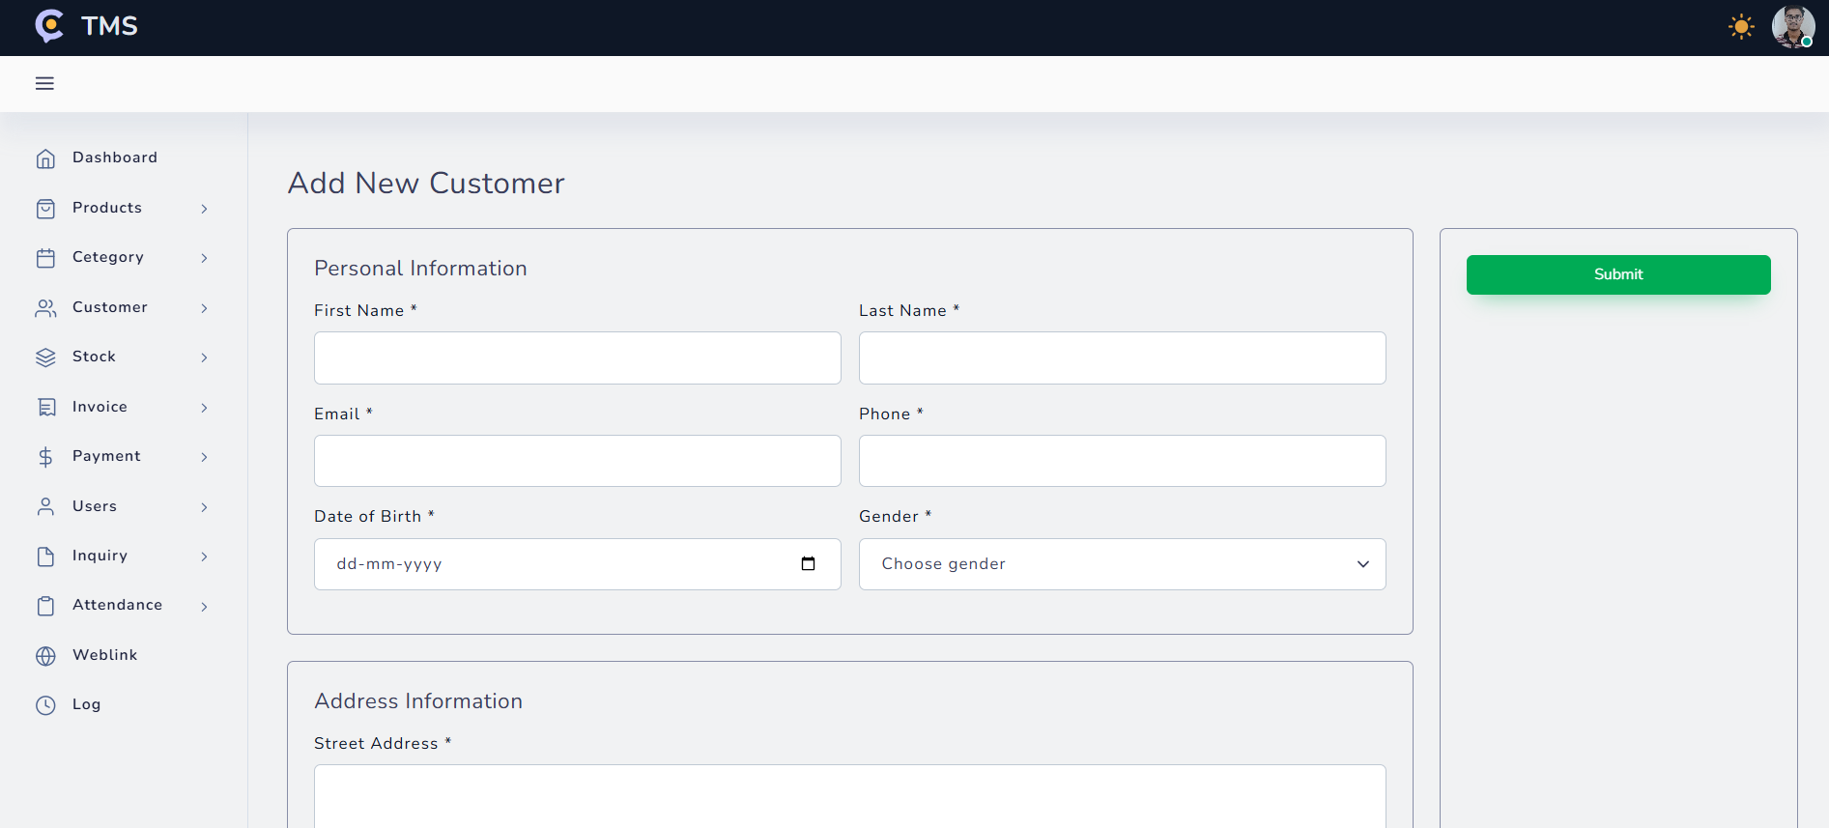

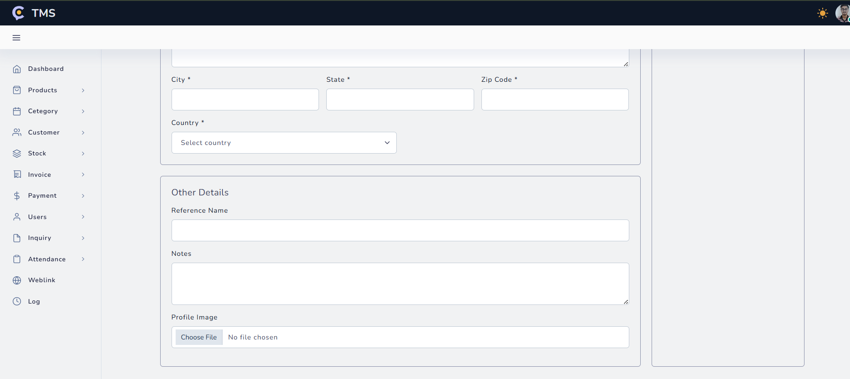

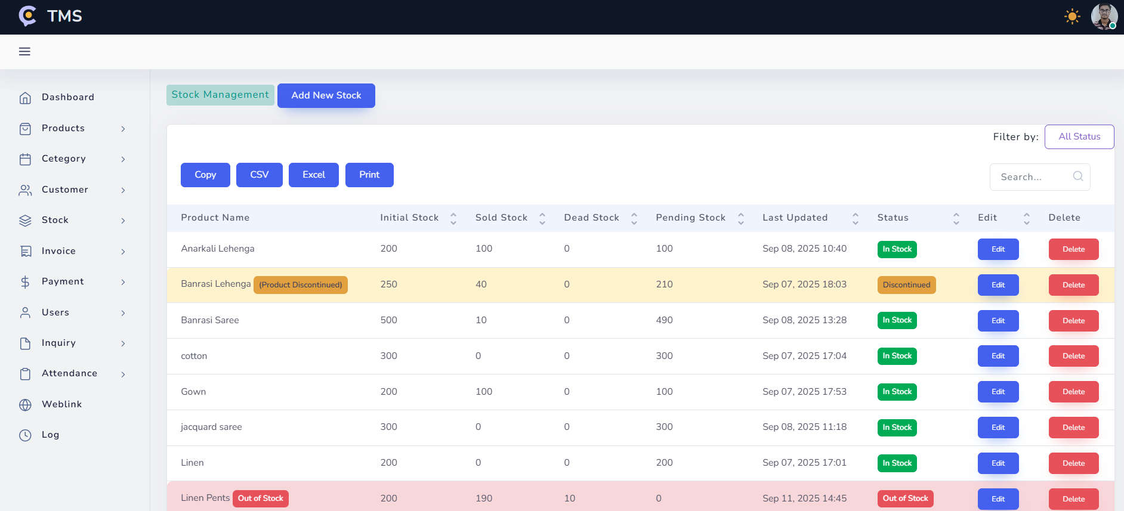

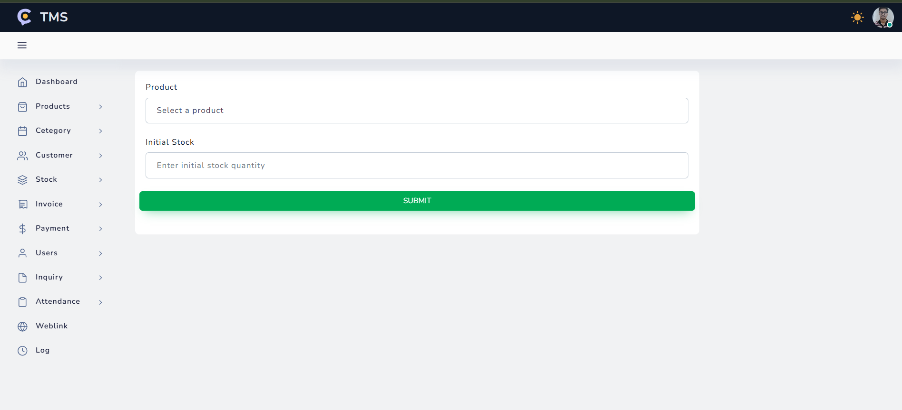

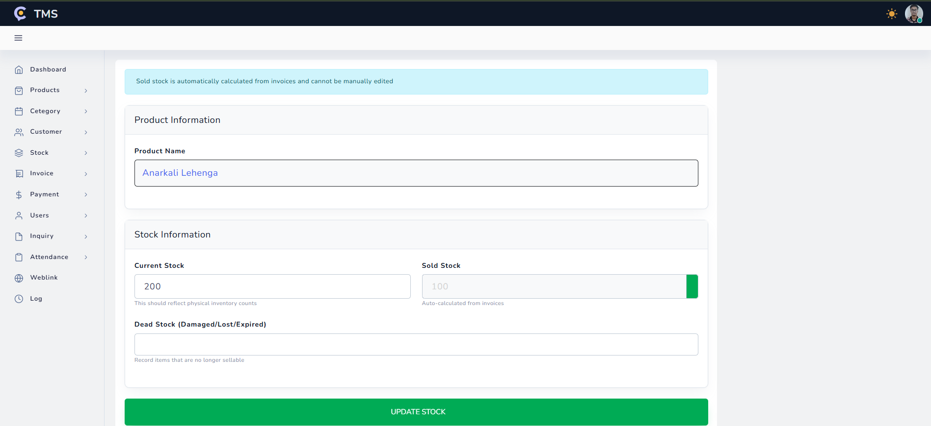

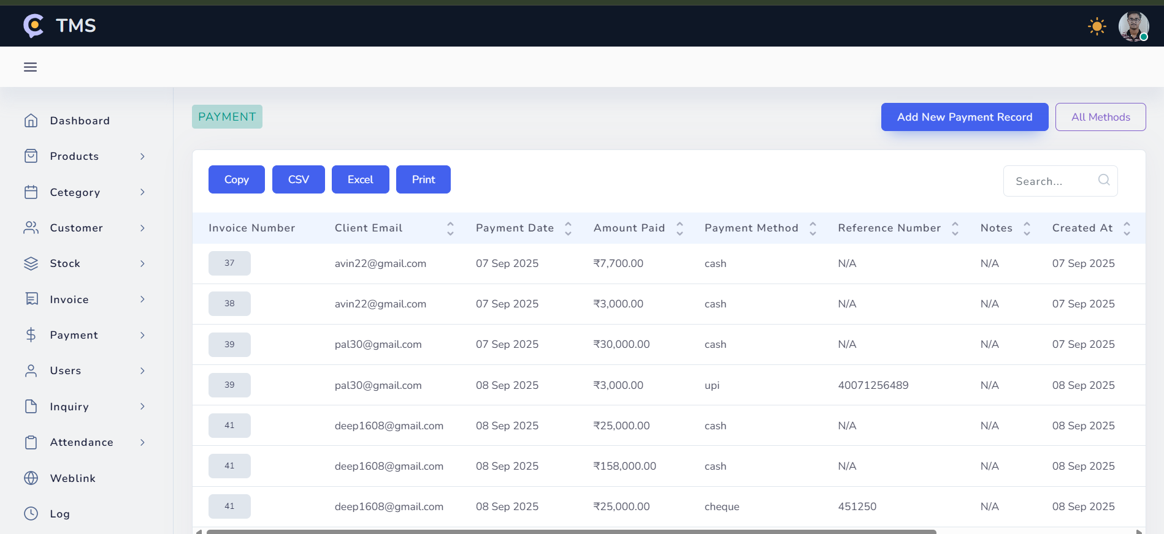

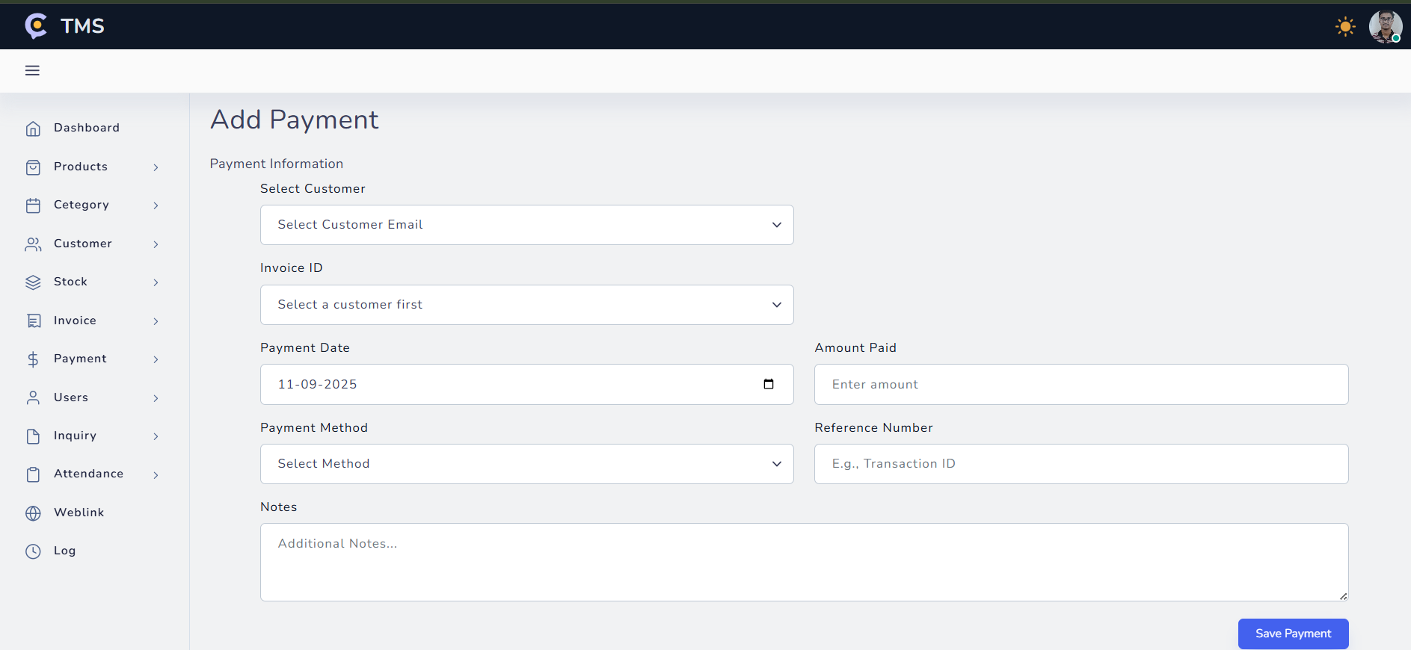

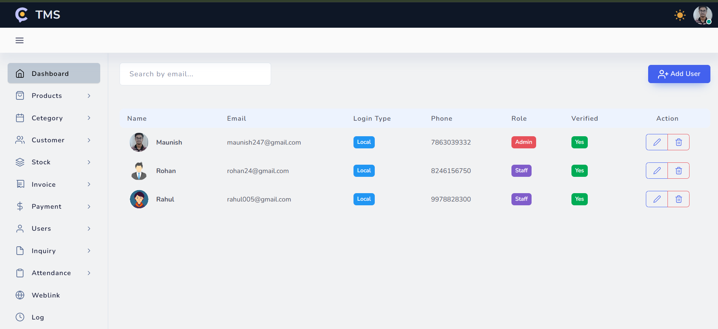

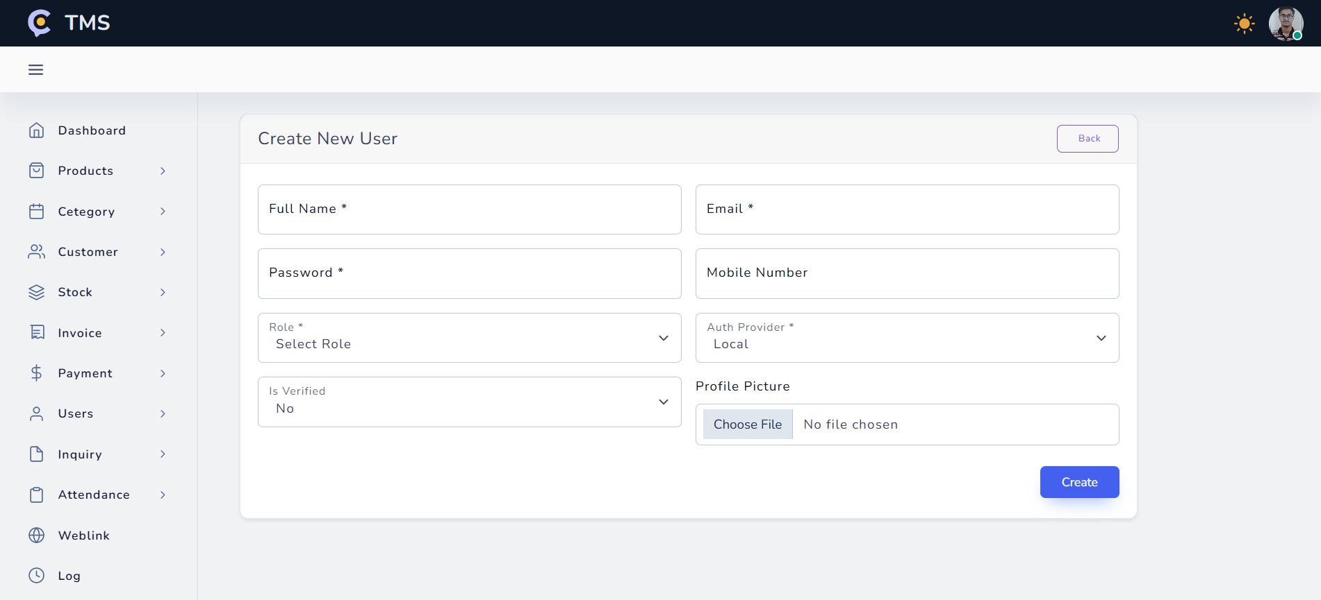

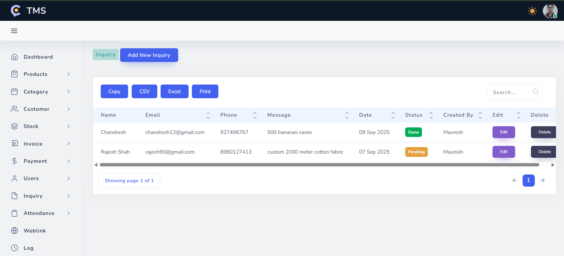

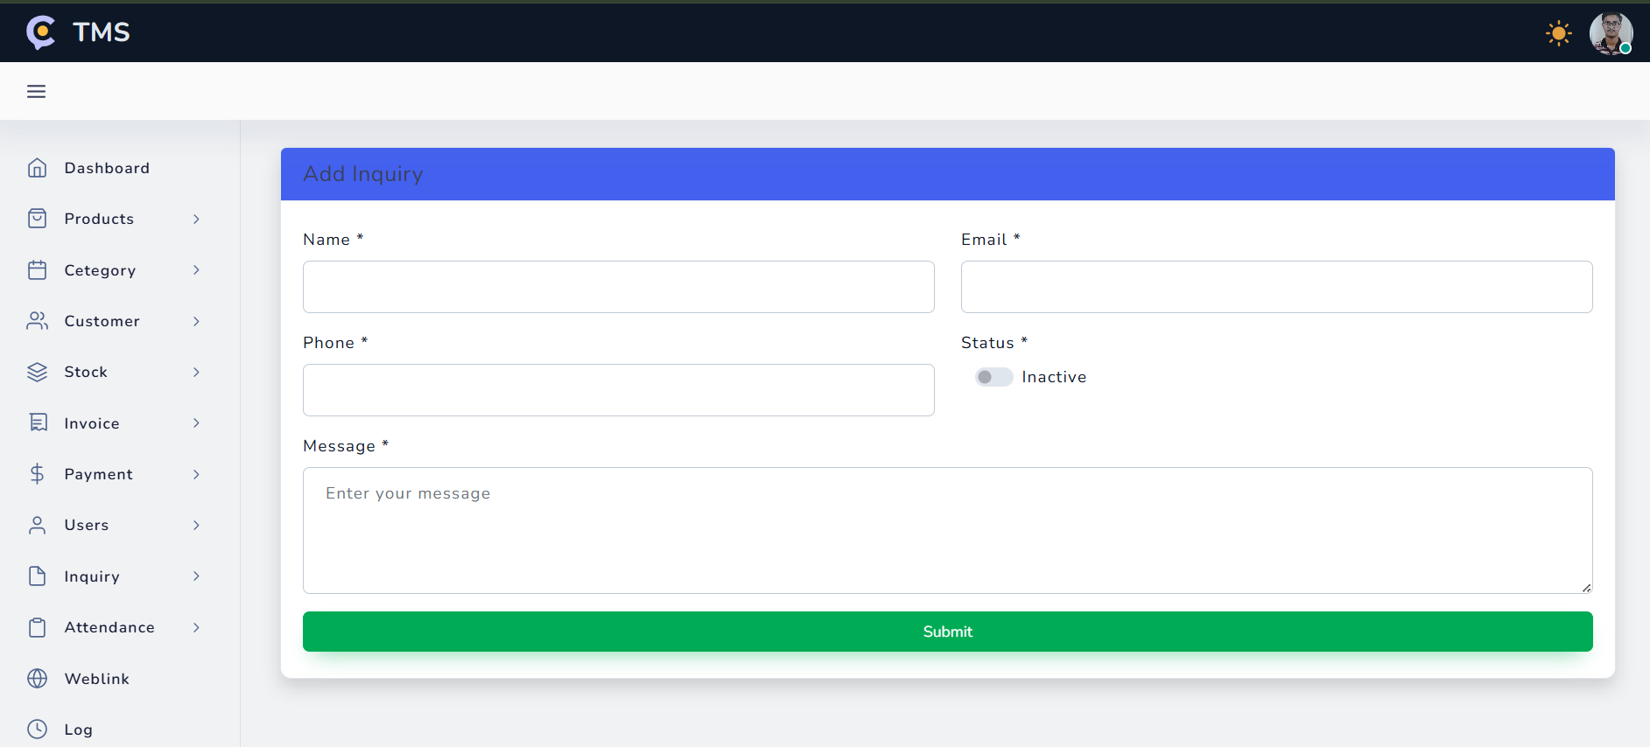

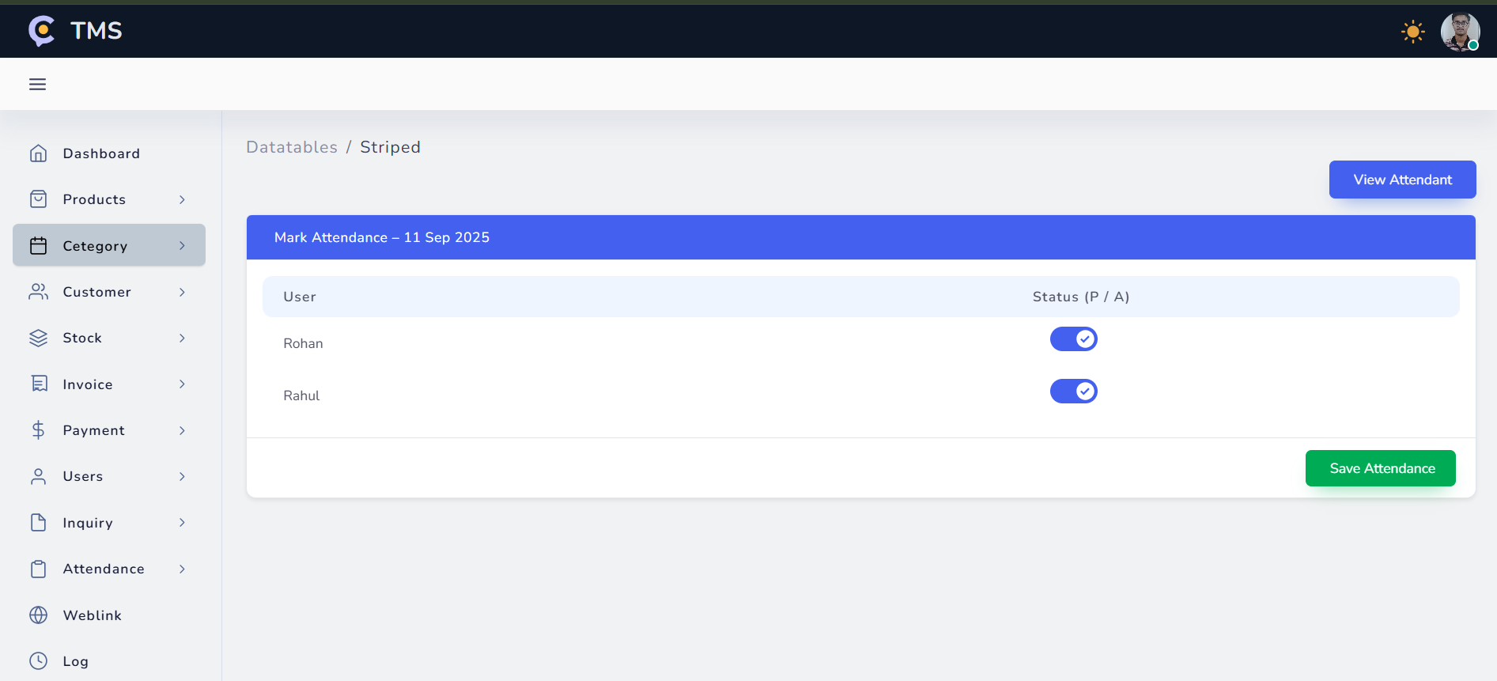

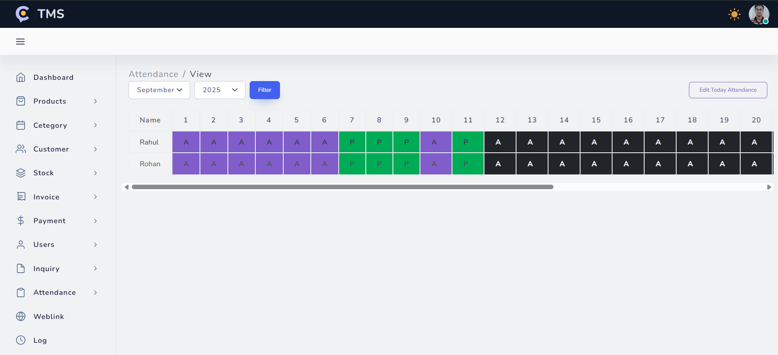

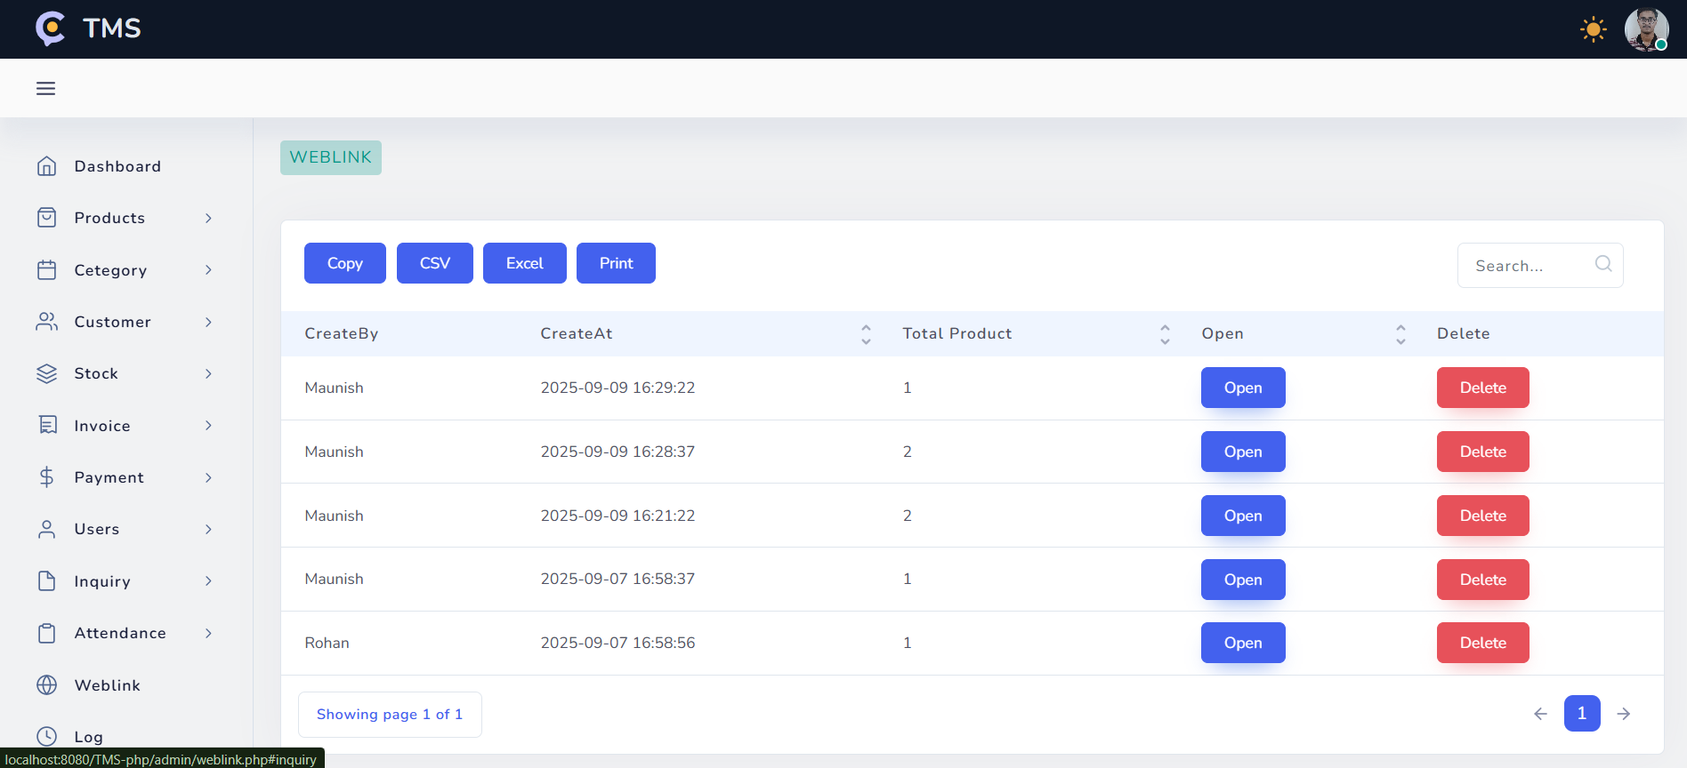

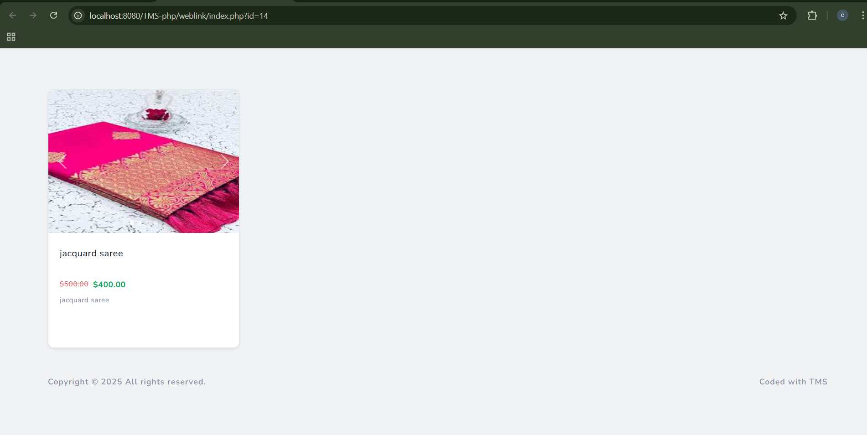

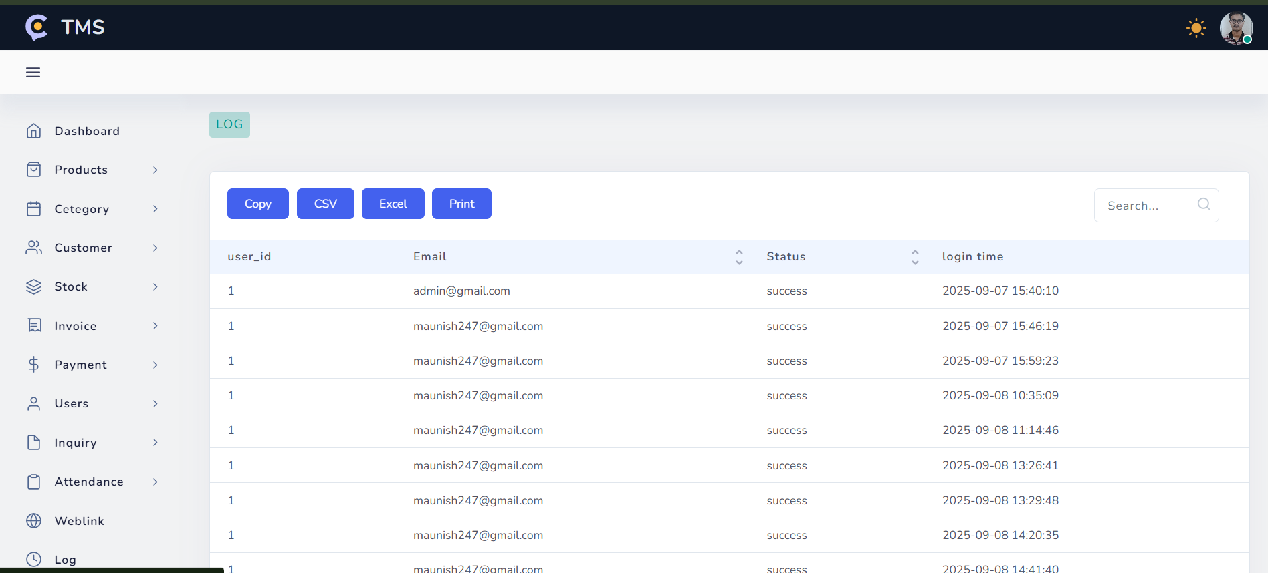

* Staff Dashboard

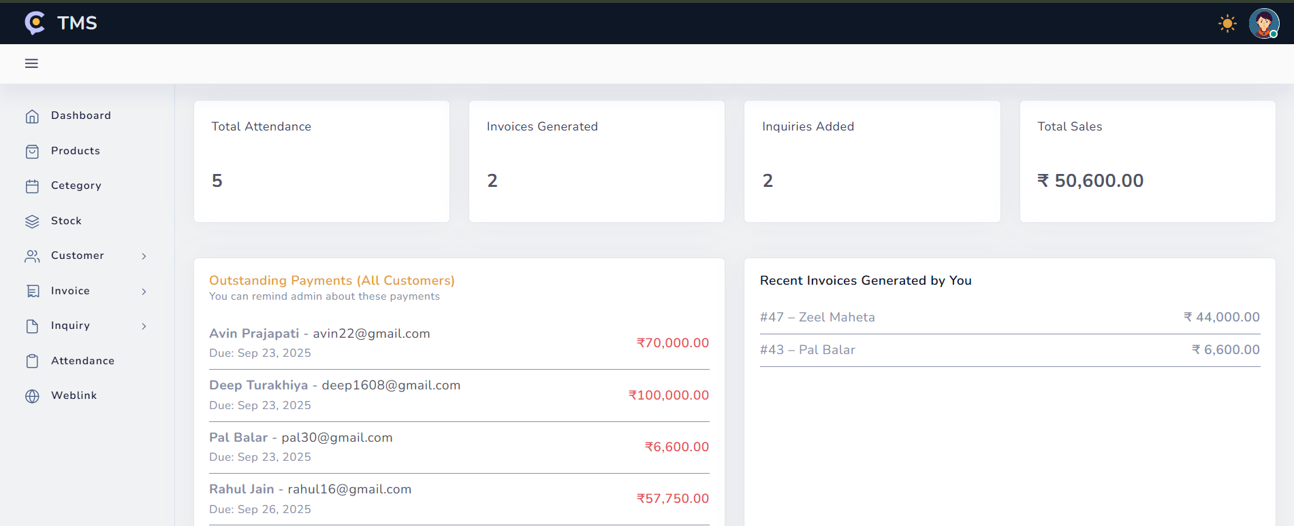

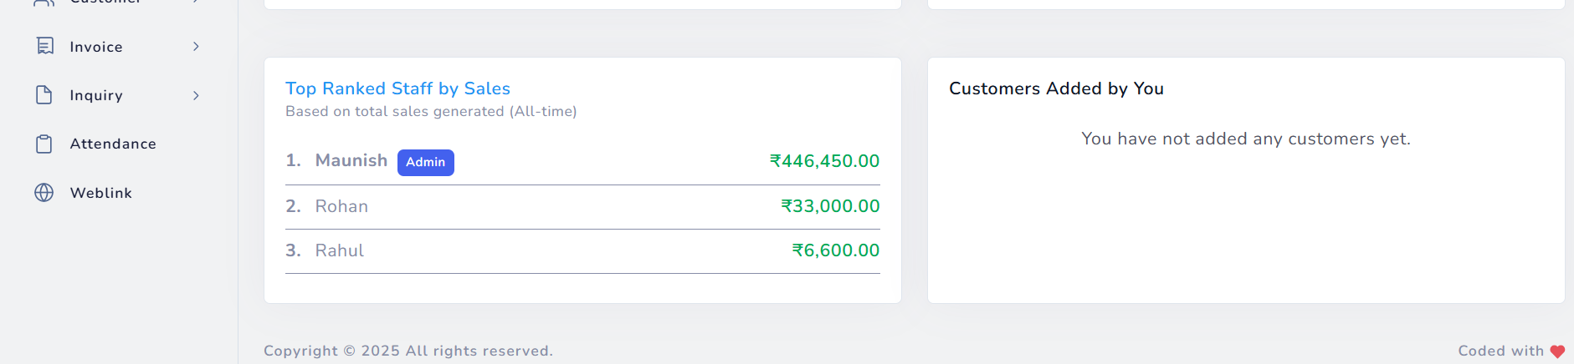

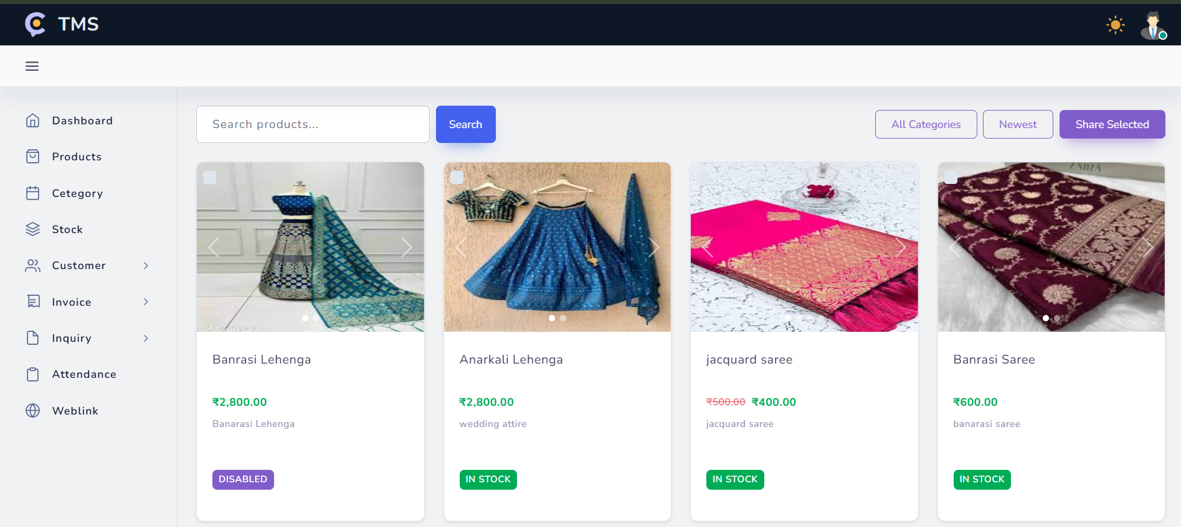

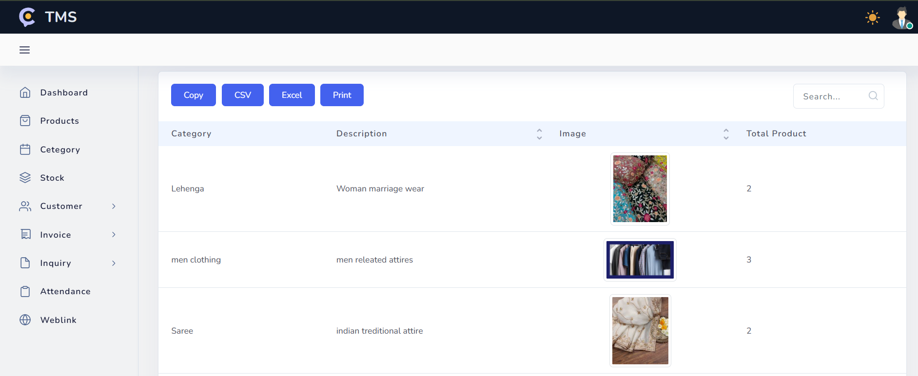

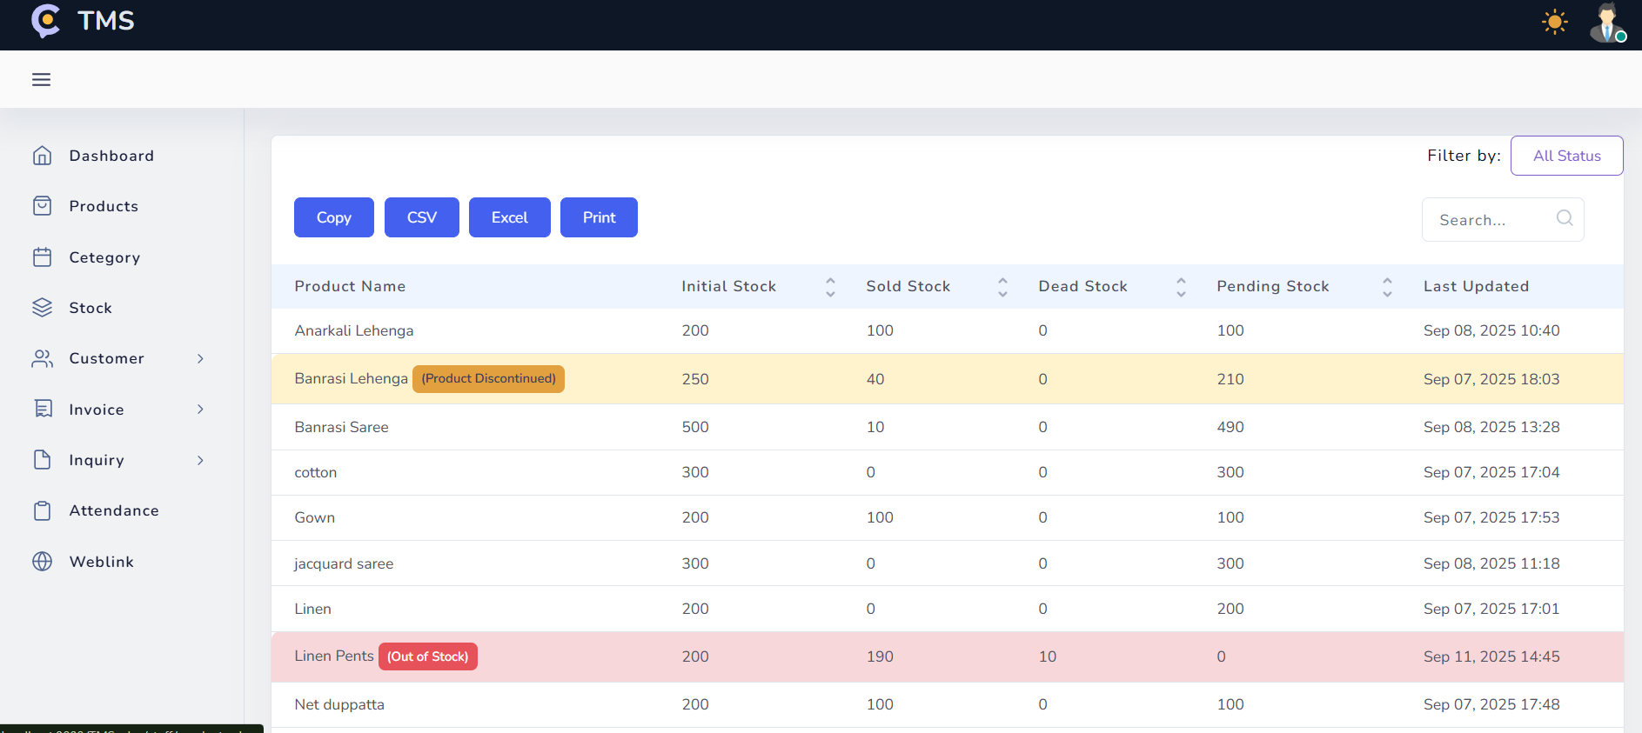

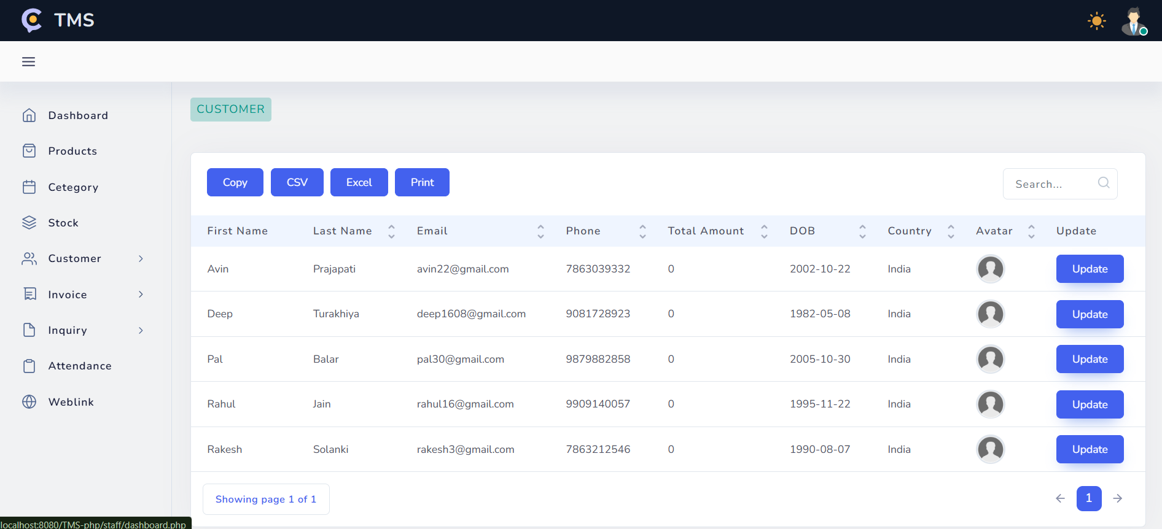

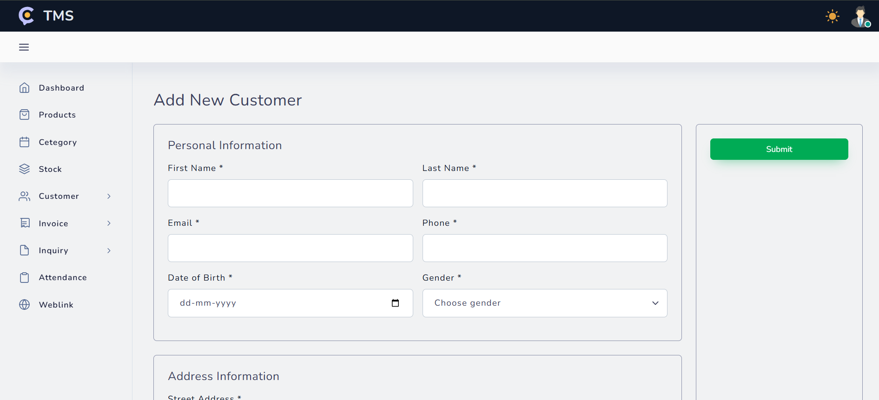

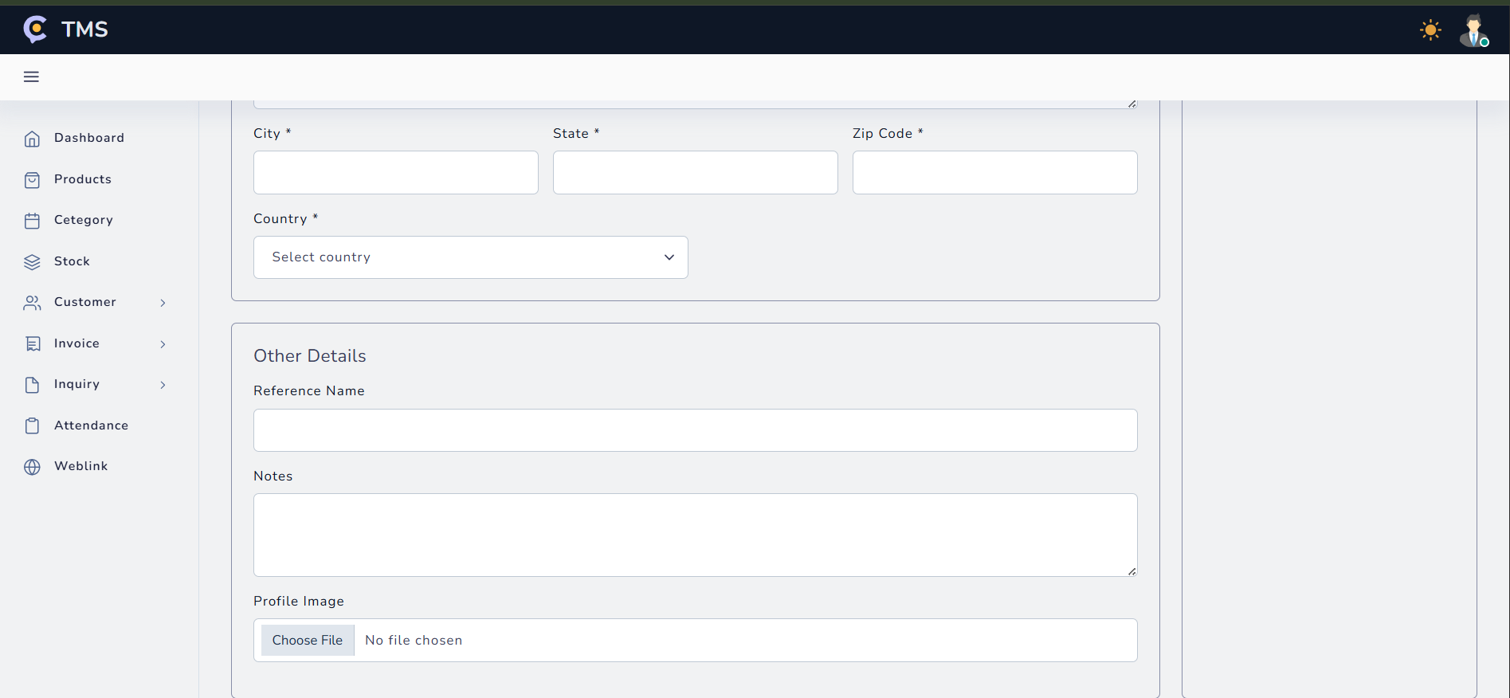

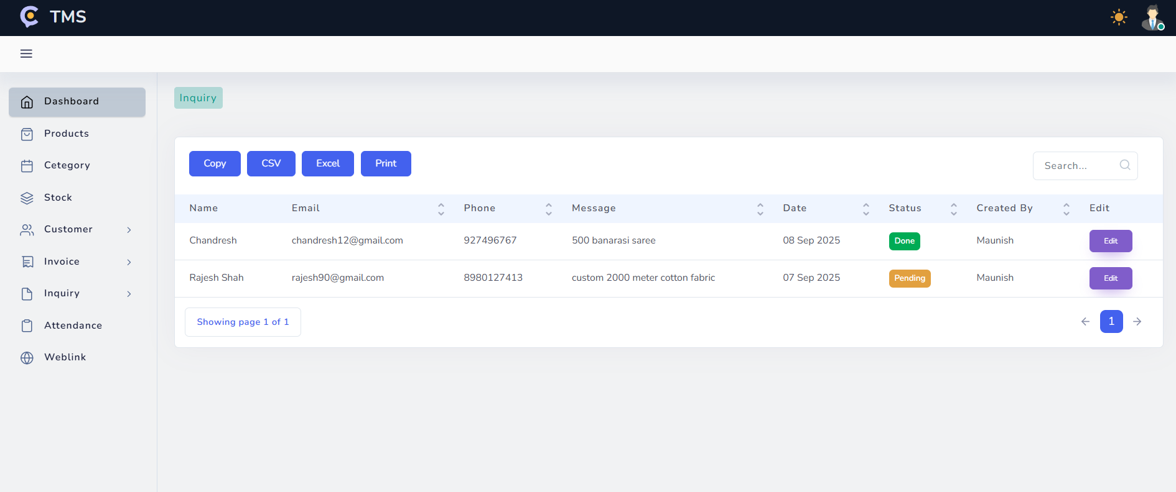

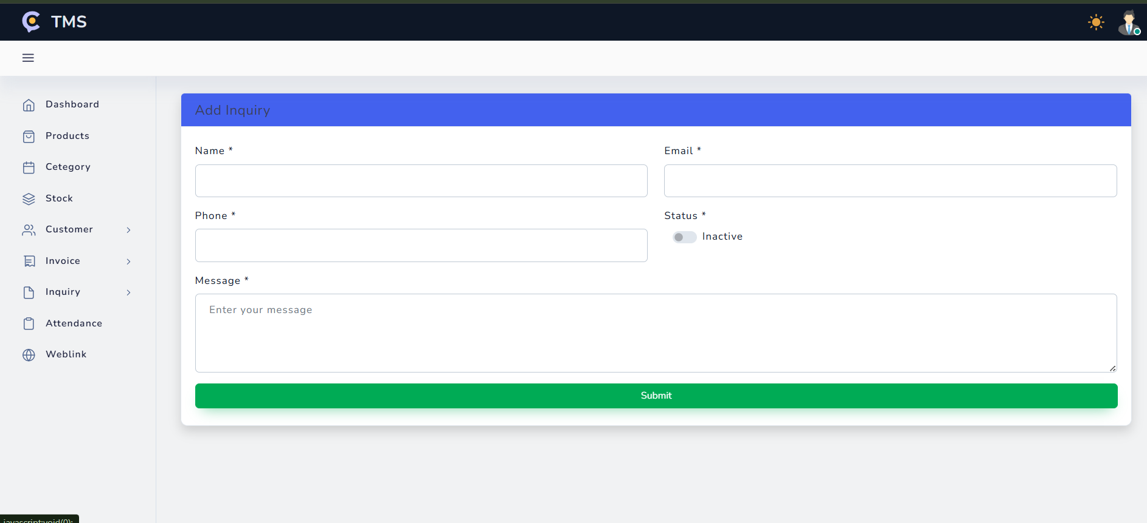

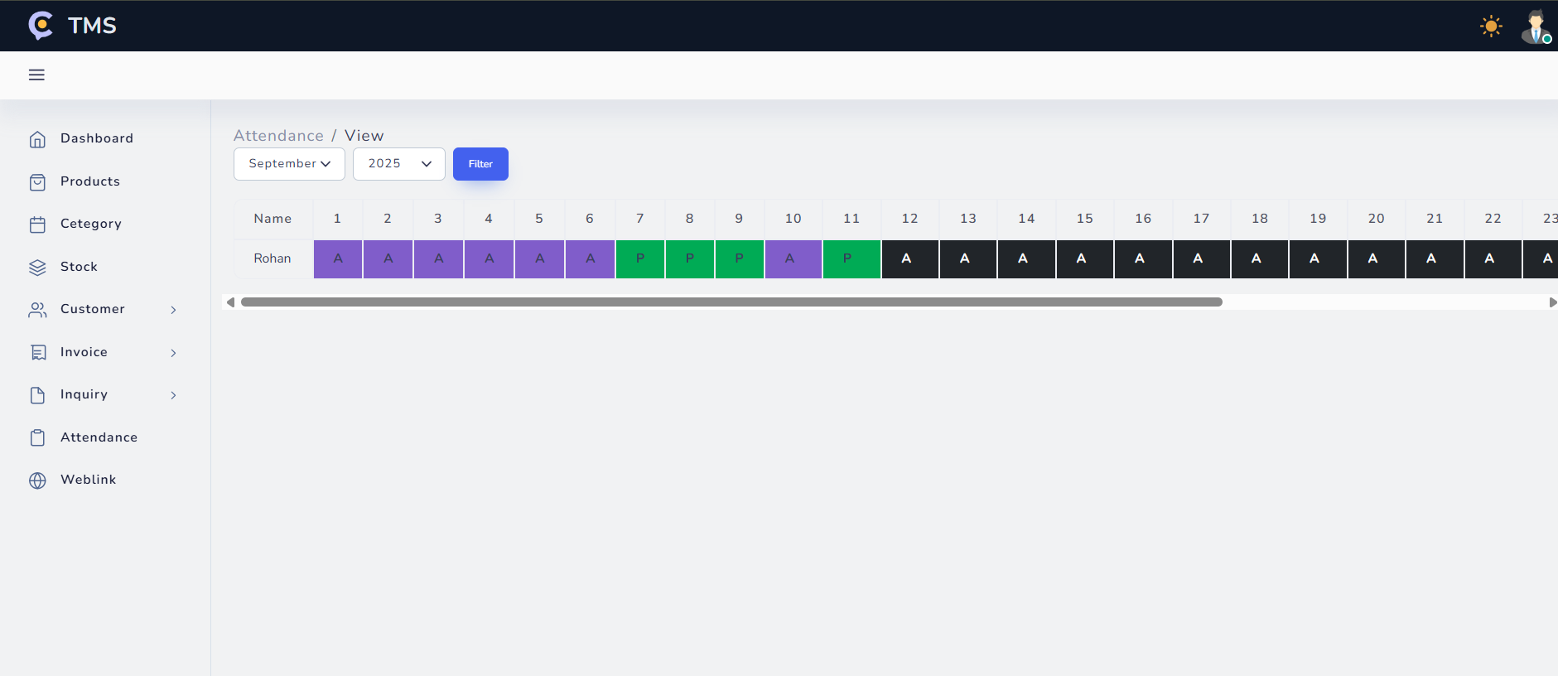

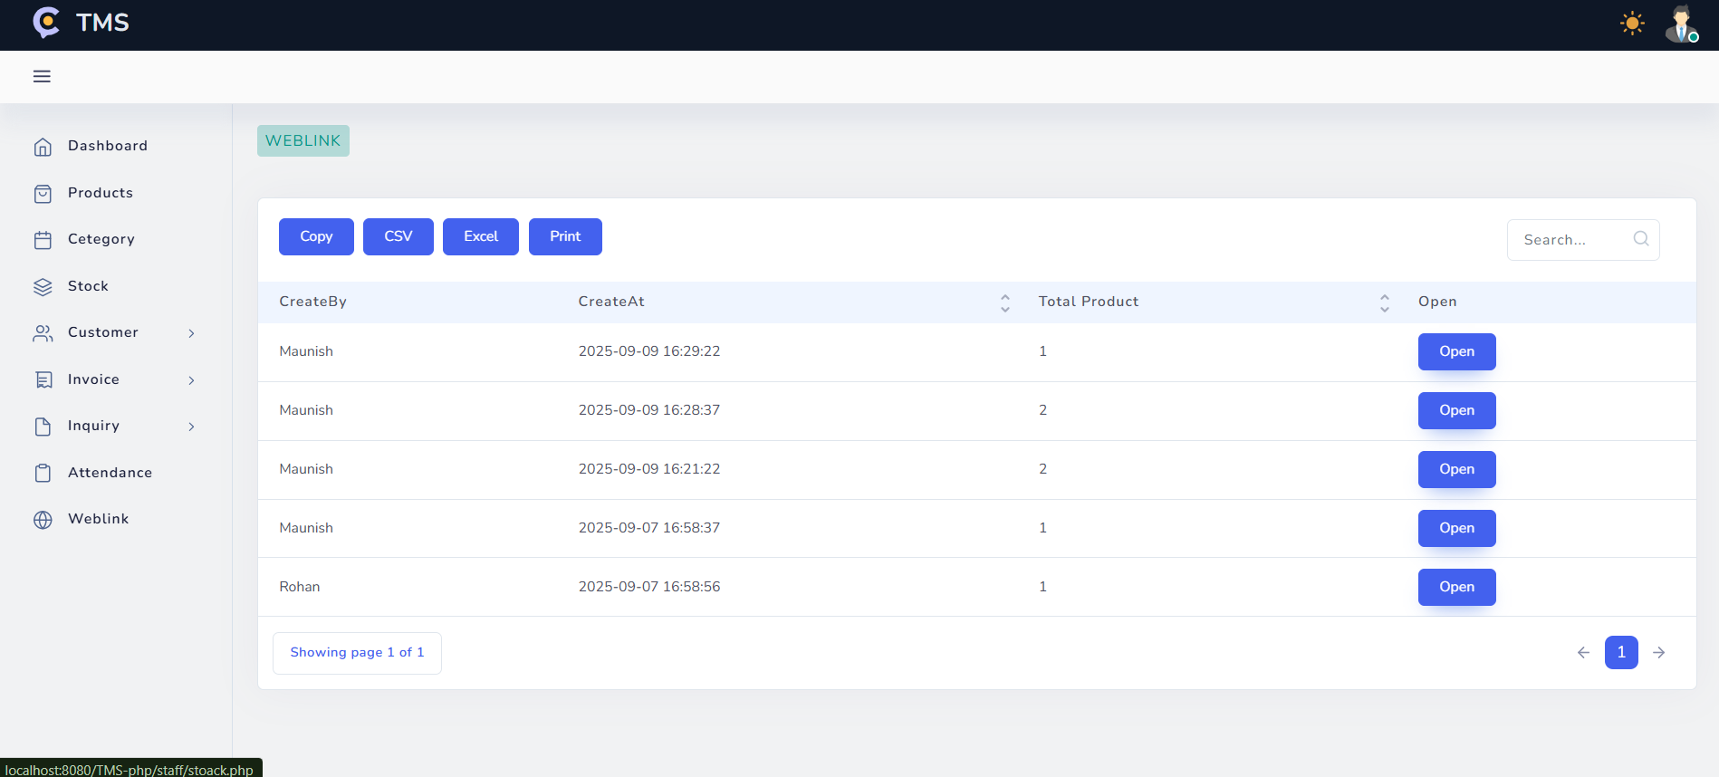

***SOFTWARE TESTING***

**UNIT TESTING:-**

Unit testing focuses verification effort on the smallest unit of software design and all the modules. The

Unit testing we have done white box oriented and some modules steps are conducted in parallel.

**WHITE BOX TESTING:-**

∙ All independent paths have been exercised at least once

∙ All logical decisions have been exercised on their true and false sides

∙ All loops are executed at their boundaries and within their operational bounds

∙ All internal data structures have been exercised to assure their validity.

**CONDITIONAL TESTING:-**

In this part of the testing each of the conditions were tested to both true and false aspects and all the resulting paths were tested. So that each path that may be generate on particular condition is traced to uncover any possible errors.

**DATA FLOW TESTING:-**

This type of testing selects the path of the program according to the location of Definition and use of variables. This kind of testing was used only when some local variable were declared. The definition-use chain method was used in this type of testing. These were

**LOOP TESTING:-**

∙ All the loops were tested at their limits, just above them and just below them.

∙ All the loops were skipped at least once.

∙ For nested loops test the inner most loop first and then work outwards.

∙ For concatenated loops the values of dependent loops were set with the help of Connected loop.

∙ Unstructured loops were resolved into nested loops or concatenated loops and tested as above.

**SYSTEM TESTING**

System testing can be divided into four related issues:

• Security

• Integrity

• Privacy

• Confidentiality

System security refers to the technical innovations and procedures applied to the hardware and operation systems to protect against deliberate or accidental damage from a defined threat.

Data security is the protection of data from loss, disclosure, modification and destruction.

System integrity refers to the power functioning of hardware and programs, appropriate physical security and safety against external threats such as eavesdropping and wiretapping.

Privacy defines the rights of the user or organizations to determine what information they are willing to share with or accept from others and how the organization can be protected against unwelcome, unfair or excessive dissemination of information about it.

Confidentiality is a special status given to sensitive information in a database to minimize the possible invasion of privacy. It is an attribute of information that characterizes its need for protection.

**PERFORMANCE TESTING**

When we are developing a design, Our concern is more on input and processing on performance time.

Performance testing is conducted prior to check the functionalities and set automation work perfectly or not.

**HUMAN FACTOR TESTING**

Human Factor Testing, also known as Usability Testing, was conducted to ensure the Textile Management System is user-friendly, efficient, and intuitive for both Admin and Staff roles. The primary goal of this testing was to verify that users can complete their tasks with ease and without confusion, aligning with the project's objective to make daily operations easier.

We focused on the following key areas:

* Ease of Learning and Navigation: We tested how easily a new user could navigate the system. The logical layout of the sidebar menu and the clarity of the dashboards were evaluated to ensure that essential modules like Products, Invoice, and Stock are easily accessible.
* Workflow Efficiency: We have tested the number of steps required to perform common tasks. For example, the invoice generation process was designed for maximum efficiency. By automatically fetching product details and only displaying items that are currently in stock, the system minimizes manual data entry and prevents the user from selling unavailable products.
* Data Entry and Error Prevention: All data input forms, such as "Add New Customer" or "Add New Product," were tested for clarity and validation. A specific test case involved trying to enter non-numeric characters into a field designed only for numbers. The system successfully rejected this invalid input, which helps prevent data corruption and user frustration.
* Clarity of Information: The dashboards for both Admin and Staff were tested to ensure that key information (kpis) like outstanding payments, sales figures, and top-selling products are presented in a clear and understandable format. This allows users to grasp the business's status at a glance.
* System Safeguards: The system was tested for features that protect against common human errors. For instance, the "Sold Stock" field cannot be edited manually by a user; it is only updated automatically when an invoice is generated. This is an intentional design choice to maintain data integrity and prevent accidental manipulation.

**WEBOGRAPHY**

* [HTTPS://ELEMENTS.ENVATO.COM/CORK-HTML-AND-LARAVEL-ADMIN-DASHBOARD-2KYQ9ZP](https://elements.envato.com/cork-html-and-laravel-admin-dashboard-2KYQ9ZP)
* [HTTPS://WWW.W3SCHOOLS.COM/](https://www.w3schools.com/php/php_forms.asp)
* [HTTPS://GOOGLE.COM/](https://google.com/)
* [HTTPS://STACKOVERFLOW.COM/](https://stackoverflow.com/)
* [HTTPS://CHAT.OPENAI.COM/](https://chat.openai.com/)
* HTTPS://WWW.YOUTUBE.COM/